CLASS COPY DO NOT TAKE!!!
Fall Final Exam Practice Problems Answers
Chunk 1 Answers
1) Democritus, Aristotle, John Dalton, JJ Thompson, Rutherford, Bohr, Schrodinger, Chadwick
2) See your notebook!
3) Hit gold foil with radioactive particles. They should have gone straight through because they thought the atom was uniform, but they bounced off sometimes in weird angles. This told them that there was a dense nucleus in the center, and the rest of the atom was mostly empty space
4) Electrons travel randomly in orbitals – that the orbitals are areas of “probability clouds” of where you are likely to find an electron, but we don’t know exactly where they are. They do not travel in circular rings/orbits like Bohr thought
5) 3.45 x 10⁻³
6) 2.98 x 10⁷
7) Should be one number then the decimal, then the rest of the numbers (2.46)
8) Should be one number then the decimal, then the rest of the numbers 5(.4)
9) Kilo
10) deci
11) meter, liter, gram
12) king henry died by drinking chocolate milk (or you may have a different one, this is just the one I’m used to)
13) 34020000 cm
14) 29400 mm
15) 2700 g
16) 0.000085 Dg
17) Protons+neutrons
18) The number of protons (and electrons if it is a neutral atom)
19) 61 neutrons
20) Cl = 17, 18, 17 Ba = 56, 81, 56 C = 6, 6, 6 Ne = 10, 10, 10
21) It has the same number of protons and electrons, but a different number of neutrons. It is the same element, just a different version of the element.
22) Carbon-12 has 6 neutrons, carbon-13 has 7, and carbon-14 has 8 neutrons
23) Br-80 = 35, 45, 35 Br-83 = 35, 48, 35
24) Bromine-80 because the average atomic mass listed on the periodic table is 79.90 and this is closer to Bromine-80 than bromine-83
25) 6.02 x 10²³
26) To help us convert from grams to molecules, because atoms are very small it is hard to count them in small “chunks” so we use the mole because it is a large “chunk” we can count in – like counting eggs by the dozen
27) You use the mass from the periodic table and you add up the mass of each atom in the molecules. You do not round because you don’t know which isotopes you are using, so you want to use the “average mass” so you are most closely going to match what you would find in nature
28) 107.87 g/mol
29) 74.1 g/mol
30) 174.27 g/mol
31) 68.17 g/mol

Chunk 2 Answers
1 | 5.63 x 10⁵ cm
2 | 1.79 m/s
3 | 1.85 x 10⁶ m/hr
4 | 1.16 x 10² mi/hr
5 | 0.27 mol
6 | 0.086 mol
7 | 3681.18 g
8 | 6.041 g
9 | 9.63 x 10²⁴ molecules
10 | 4.15 x 10⁷ mol
11 | Area where an e- is most likely to be found, also called a probability cloud
12 | 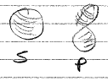
13 | 2
14 | 2, 6, 10, 14
15 | 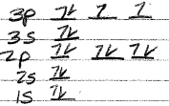
16 | 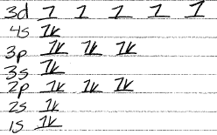
17 | Fill bottom to top, 2 e- per orbital, one e- in each p or
18 | Ge
19 | K
20 | 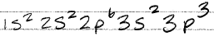
21
22 | 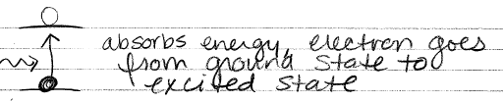
23 | 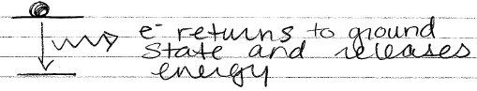
24 | Ground state = lowest energy level an e- can be in  Excited state = a higher energy level than normal
25 | 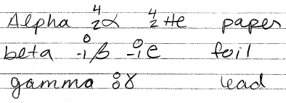
26 | Gamma, beta, alpha
27 | 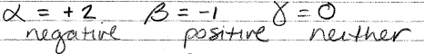
28 | 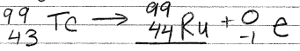
29 | 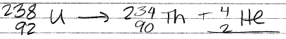
30 | 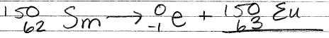

Chunk 3 Answers
1 | 0.0394 mg
2 | 6.25%
3 | 46.87 g
4 | 3.61 x 10⁻¹² g
5 | +1, +2, -1, 0
6 | 1, 1, 2, 7, 6, 6, 4, 3
7 | 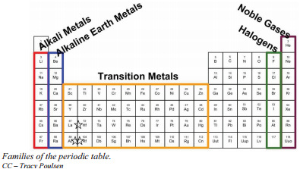
8 | (Answers may vary)
9 | 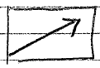
10 | Fr, Na, Ca, Fe, S, F
11
12 | Fr, Na, Ca, Fe, S, F
13
14 | F, S, Fe, Ca, Na, Fr
15 | CO₃²⁻  PO₄³⁻  Fe³⁺  NO₃⁻
16 | Ionic: cation + anion OR metal + nonmetal  Binary: cation keeps normal name, add roman numeral if transition metal, change anion to -ide  Polyatomic: use ion names from common ions list  Covalent: use prefixes, last element change end to -ide
17 | Tetranitrogen decoxide  Aluminum oxide  Tetraphosphorus decasulfide  Zinc sulfate  Copper (II) chloride  Ammonium nitrite  Carbon tetrachloride  Calcium chlorite  Pentacarbon monoiodide
18 | Ga₂O₃  CaCl₂  (NH₃)PO₃  CaO₂
19 | P₂O  S₄F₃  NH₄
20 | Metal + nonmetal, nonmetal + nonmetal, metal + metal
21 | Transfer, share, “sea” of free-flowing electrons
22 | I, I, C, M, C, C
23 | Most atoms want 8 valence e-
24 | H = 2  B = 6  P = 10  S = 12
25 | 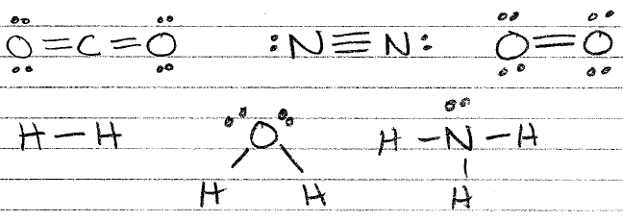
29 | Single: H₂, H₂O, NH₃  Double: CO₂, O₂  Triple: N₂  Lone pairs: CO₂ , H₂O, NH₃, N₂, O₂
30 | 