1). | Find the volume of an object that has a density of 3.14 g/mL and a mass of 71.5 g.
 | A) | 22.8 mL
 | B) | 4.39 x 10^{–2} mL
 | C) | 225 mL
 | D) | 2.28 x 10^{–2} mL

2) | Which of the following involves no chemical change?
 | A) | burning paper
 | B) | boiling water
 | C) | baking a cake
 | D) | lighting a match

3) | How many protons, electrons, and neutrons, respectively, does have?
 | A) | 53, 127, 74
 | B) | 53, 53, 127
 | C) | 74, 53, 127
 | D) | 53, 53, 74

4) | Perform the following conversion:  5.80 m/s = __________ mi/h
 | A) | 0.386 mi/h
 | B) | 13.0 mi/h
 | C) | 277. mi/h
 | D) | 216. mi/h

5) | A d sublevel can hold a maximum of
 | A) | 5 electrons
 | B) | 10 electrons
 | C) | 14 electrons
 | D) | 32 electrons

6) | Which electron configuration indicates a transitional element?
 | A) | 1s²2s²2p⁶3s¹3p⁶
 | B) | 1s²2s²2p⁶3s²3p⁶4s²3d³
 | C) | 1s²2s²2p⁵
 | D) | 1s²2s²2p⁶3s²3p⁶4s²3d¹⁰4p²

7) | When an electron in the ground state absorbs energy, it goes to a(n) ______________ state.
 | A) | excited
 | B) | lower
 | C) | frenetic
 | D) | ionic

8). | Thorium-234 undergoes beta particle production. What is the other product?
 | A)
 | B)
 | C)
 | D)

9) | A particular radioactive element has a half-life of 8.53 days. What percent of the original sample is left after 15.0 days?
 | A) | 54.4%
 | B) | 14.8%
 | C) | 59.1%
 | D) | 29.6%

10) | Rank the following from smallest to largest atomic radius.
 | A) | O, Zn, Ca, Ba
 | B) | O, Ca, Zn, Ba
 | C) | Ba, Ca, Zn, O
 | D) | O, Zn, Ba, Ca

11) | The name of the ClO₂⁻ ion is
 | A) | chlorite
 | B) | chloride
 | C) | hypochlorate
 | D) | perchlorate

12) | Which of the following compounds contains one or more covalent bonds?
 | A) | NaCl
 | B) | CaO
 | C) | CO₂
 | D) | Cs₂O

13) | The correct name for FeO is
 | A) | iron oxide
 | B) | iron(II) oxide
 | C) | iron monoxide
 | D) | iron(I) oxide

14) | The Lewis structure for which of the following contains the greatest number of lone pairs of electrons?
 | A) | CH₄
 | B) | HF
 | C) | F₂
 | D) | H₂O

15) | The boiling point of CH4 is much lower than that of HF. This is because:
 | A) | of London forces in CH4
 | B) | of Hydrogen bonding in HF
 | C) | of Dipole-Dipole interactions in CH4
 | D) | CH4 is polar
 | E) | HF is heavier

16) | Which of the following is the formula for aluminum oxide?
 | A) | AlO
 | B) | AlO₂
 | C) | AlO₃
 | D) | Al₃O₂
 | E) | Al₂O₃

17) | Choose the correct energy level diagram for the ground state of oxygen.
 | A) | 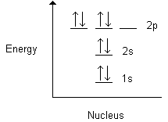
 | B) | 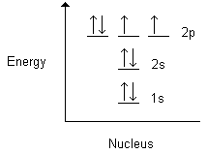
 | C) | 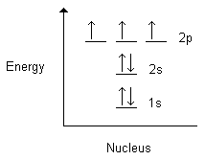
 | D) | 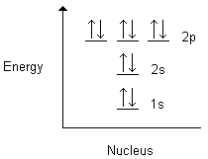
 | E) | 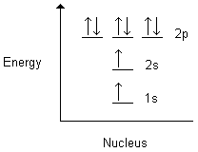

18) | Which is an isotope of Iodine?
 | A) | 53 protons, 53 electrons, 74 neutrons
 | B) | 50 protons, 53 electrons, 77 neutrons
 | C) | 53 protons, 53 electrons, 77 neutrons
 | D) | 53 protons, 50 electrons, 127 neutrons
 | E) | 50 protons, 50 electrons, 127 neutrons

19) | 2.5 kilogram(s) contains this many grams:
 | A) | 2.5 x 10²
 | B) | 2.5 x 10³
 | C) | 25
 | D) | 0.25
 | E) | 2.5 x 10⁻³

20) Express 9230000 in scientific notation
A) 923 x 10²
B) 9.23 x 10⁶
C) 9.23 x 10⁻⁶
D) 92.3 x 10⁸

21) Which metric prefix is used to designate 100?
A) H
B) m
C) B
D) c
E) d

22) | Which of the following would be expected to be the strongest?
 | A) | Ionic
 | B) | Covalent
 | C) | Network covalent
 | D) | Hydrogen bonding
 | 23) | Which of the following is an intramolecular force?
 | A) | Ionic
 | B) | Hydrogen bond
 | C) | London Force
 | D) | Polarity
 | 24) | Which of the following is a polar molecule?
 | A) | CO₂
 | B) | SiCl₄
 | C) | CaBr₂
 | D) | CH₃OH
 | 25) | Alpha particles are
 | A) | electrons
 | B) | protons
 | C) | neutrons
 | D) | helium nuclei
 | E) | X rays
 | 26) | Which of the following elements is an alkaline earth metal?
 | A) | Ca
 | B) | Cu
 | C) | Fe
 | D) | Na

27) | Which of the following would hydrogen bond?
A) | CH₂O
B) | CH₄
C) | CH₃OH
D) | C₂H₅Br

