Common Laboratory Equipment & Techniques
Safety Splash Goggles  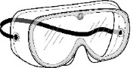 |  | Beaker  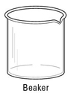 | Erlenmeyer Flask  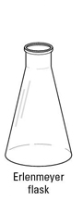 |  | Graduated Cylinder  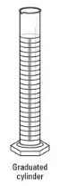 | Distilled Water Wash Bottle  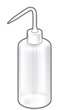
Test Tubes  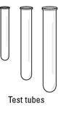 |  | Volumetric Flask  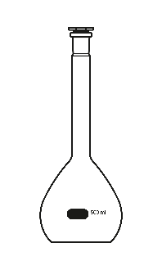 | Spatulas and Scoopulas  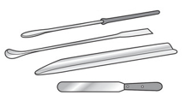 |  | Disposable Pipette  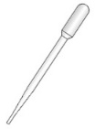 | Rubber Policeman  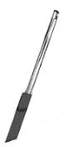
Beaker Tongs  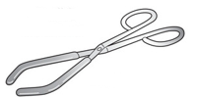 |  | Crucible Tongs  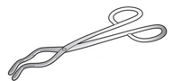 | Test Tube Tongs  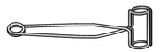 |  | Hot Plate  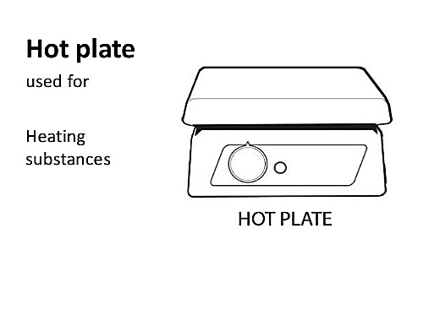 | Bunsen Burner  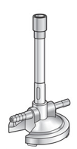
Flint Striker  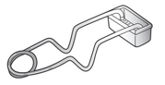 |  | Ring Stand  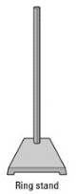 | Iron Support Ring  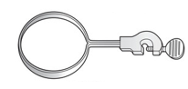 |  | Wire Gauze with  Clay Center  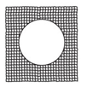 | Crucible with Lid  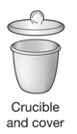
Test Tube Rack  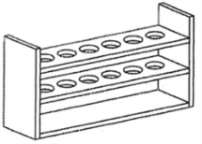 |  | Test Tube Brush  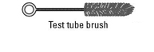 | Rubber Stoppers  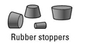 |  | Glass Watch Glass  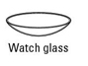 | Morter and Pestle  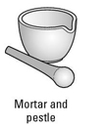
Filter Flask  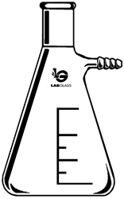 |  | Buchner Funnel  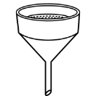 | Aspirator for Sink  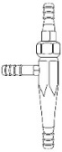 |  | Glass Funnel  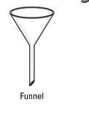 | Evaporating Dish  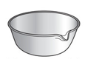
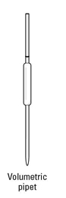  Volumetric Pipette |  | Rubber Pipette Bulb  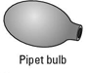 | Forceps  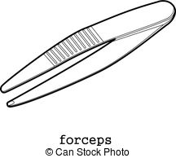 |  | Burette Clamp  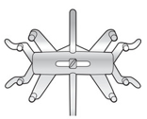 | Burette  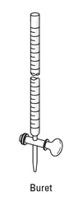
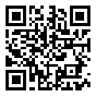SCAN ME | Common Lab Techniques:  https://tinyurl.com/3eyn4faa |  |  | You will sometimes be asked to look at certain sections of this Common Lab Techniques PowerPoint as part of your “Pre-Lab” assignments. This will maximize our in class lab time and help ensure that you are safe in the lab.

