Naming Covalent Molecules  www.tinyurl.com/pjfrgq9  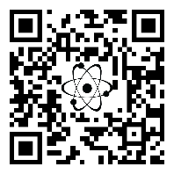 | Naming Covalent Molecules  www.tinyurl.com/pjfrgq9 | Naming Covalent Molecules  www.tinyurl.com/pjfrgq9 | Naming Covalent Molecules  www.tinyurl.com/pjfrgq9  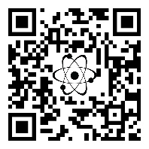 | Naming Covalent Molecules  www.tinyurl.com/pjfrgq9 | Naming Covalent Molecules  www.tinyurl.com/pjfrgq9 | Naming Covalent Molecules  www.tinyurl.com/pjfrgq9
Naming Covalent Molecules  www.tinyurl.com/pjfrgq9 | Naming Covalent Molecules  www.tinyurl.com/pjfrgq9 | Naming Covalent Molecules  www.tinyurl.com/pjfrgq9 | Naming Covalent Molecules  www.tinyurl.com/pjfrgq9 | Naming Covalent Molecules  www.tinyurl.com/pjfrgq9 | Naming Covalent Molecules  www.tinyurl.com/pjfrgq9 | Naming Covalent Molecules  www.tinyurl.com/pjfrgq9
Naming Covalent Molecules  www.tinyurl.com/pjfrgq9 | Naming Covalent Molecules  www.tinyurl.com/pjfrgq9 | Naming Covalent Molecules  www.tinyurl.com/pjfrgq9 | Naming Covalent Molecules  www.tinyurl.com/pjfrgq9 | Naming Covalent Molecules  www.tinyurl.com/pjfrgq9 | Naming Covalent Molecules  www.tinyurl.com/pjfrgq9 | Naming Covalent Molecules  www.tinyurl.com/pjfrgq9
Naming Covalent Molecules  www.tinyurl.com/pjfrgq9 | Naming Covalent Molecules  www.tinyurl.com/pjfrgq9 | Naming Covalent Molecules  www.tinyurl.com/pjfrgq9 | Naming Covalent Molecules  www.tinyurl.com/pjfrgq9 | Naming Covalent Molecules  www.tinyurl.com/pjfrgq9 | Naming Covalent Molecules  www.tinyurl.com/pjfrgq9 | Naming Covalent Molecules  www.tinyurl.com/pjfrgq9
Naming Covalent Molecules  www.tinyurl.com/pjfrgq9 | Naming Covalent Molecules  www.tinyurl.com/pjfrgq9 | Naming Covalent Molecules  www.tinyurl.com/pjfrgq9 | Naming Covalent Molecules  www.tinyurl.com/pjfrgq9 | Naming Covalent Molecules  www.tinyurl.com/pjfrgq9 | Naming Covalent Molecules  www.tinyurl.com/pjfrgq9 | Naming Covalent Molecules  www.tinyurl.com/pjfrgq9

