**Pictionary Review Instructions**

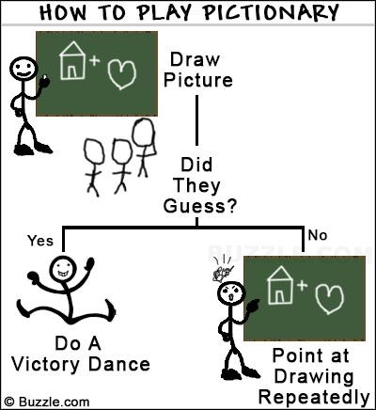

1. Make two teams
2. One player from Team A draws a word from the cup and tries to draw a picture of the word on the whiteboard. Player has 30 seconds to draw the word. You can use a timer on your phone to keep track of the time.
3. Other Team A players try to guess the word.
4. If Team A guesses correctly they score a point. If they do not get it correct then Team B has a chance to “steal” the point by guessing correctly.
5. You may not talk, spell or use words, you may not gesture or mime anything either! This is Pictionary not charades!
6. Everyone records the word and picture onto their worksheet when the round is over. If the picture drawn wasn’t very good, hard to understand etc then you may draw your own image. You need a record of which words you used so you can do your homework assignment!
7. Team B goes and repeats steps 2-6. Repeat alternating teams until class is almost over.
8. When class is almost over, have your drawing paper stamped and pick up the homework paper that goes with the drawings you did.
9. You will turn in both papers on Tuesday for points.

**Pictionary Review Instructions**



1. Make two teams
2. One player from Team A draws a word from the cup and tries to draw a picture of the word on the whiteboard. Player has 30 seconds to draw the word. You can use a timer on your phone to keep track of the time.
3. Other Team A players try to guess the word.
4. If Team A guesses correctly they score a point. If they do not get it correct then Team B has a chance to “steal” the point by guessing correctly.
5. You may not talk, spell or use words, you may not gesture or mime anything either! This is Pictionary not charades!
6. Everyone records the word and picture onto their worksheet when the round is over. If the picture drawn wasn’t very good, hard to understand etc then you may draw your own image. You need a record of which words you used so you can do your homework assignment!
7. Team B goes and repeats steps 2-6. Repeat alternating teams until class is almost over.
8. When class is almost over, have your drawing paper stamped and pick up the homework paper that goes with the drawings you did.
9. You will turn in both papers on Tuesday for points.