Phases and Changes

**Directions:**You will set up your notes as you see below. Read the following reading selection and take notes in your notebook. When you are done you will answer some practice problems to make sure you understood the concepts. These terms will be used in our labs a lot so they are important to learn!

**Target: I can distinguish between a chemical and physical change/property and describe the difference on a molecular level.**

Physical Properties Physical Changes

Chemical Properties Chemical Changes

**K . C . Q .**

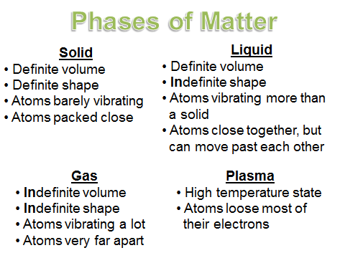 **REMEMBER THE PHASES OF MATTER!**

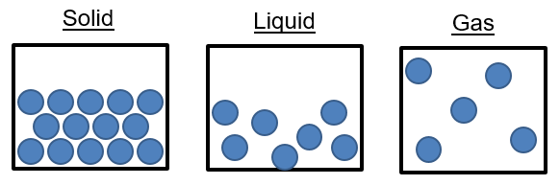

**PHASE CHANGES –** When you change from one phase of matter to another phase of matter

Phase changes that absorb energy, molecules are spreading further away from each other.

Solid 🡪 Liquid *melting*

Liquid 🡪 Gas *vaporizing*

Solid 🡪 Gas *sublimation*

Phase changes that release energy, molecules are getting closer to each other.

Liquid 🡪 Solid *freezing*

Gas 🡪 Liquid *condensing*

Gas 🡪 Solid *deposition*

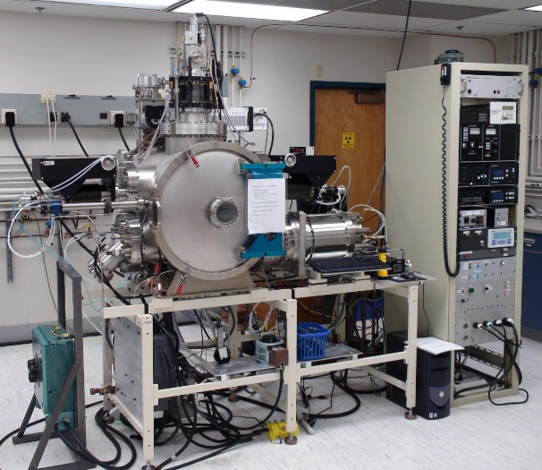 *Sublimation and deposition are not very common phase changes   
that we would see in real life. Dry ice going from a solid block to   
the white cloud of vapor is sublimation. When water vapor in the   
atmosphere is at the exact right pressure and temperature the gas   
water molecules will instantly turn into snowflakes. That is an   
example of deposition. This is a picture of a deposition chamber   
that is used in the lab. Mrs. Farmer used to use one of these in   
graduate school to make computer chips that had very specific   
properties. It is about ¼ the size of our classroom! There are gas   
elements inside and you can change the pressure and temperature  
to instantly have them “deposit” down onto a silicon wafer to form a  
solid row of atoms. This allows you to layer different elements onto   
the wafer in layers that are one atom thick, two atoms thick, etc.*