Density of Pennies Prelab
- You must make a collage of pictures from the internet or magazines that shows what you will do in the lab
  - Must show STEP BY STEP what you are going to do…in order!
  - Must show things like the equipment, what you will do with it, etc.
  - Must use multiple pictures!
  - For each picture include a ONE SENTENCE explanation of the step.
  - Your final collage should take up the whole page!

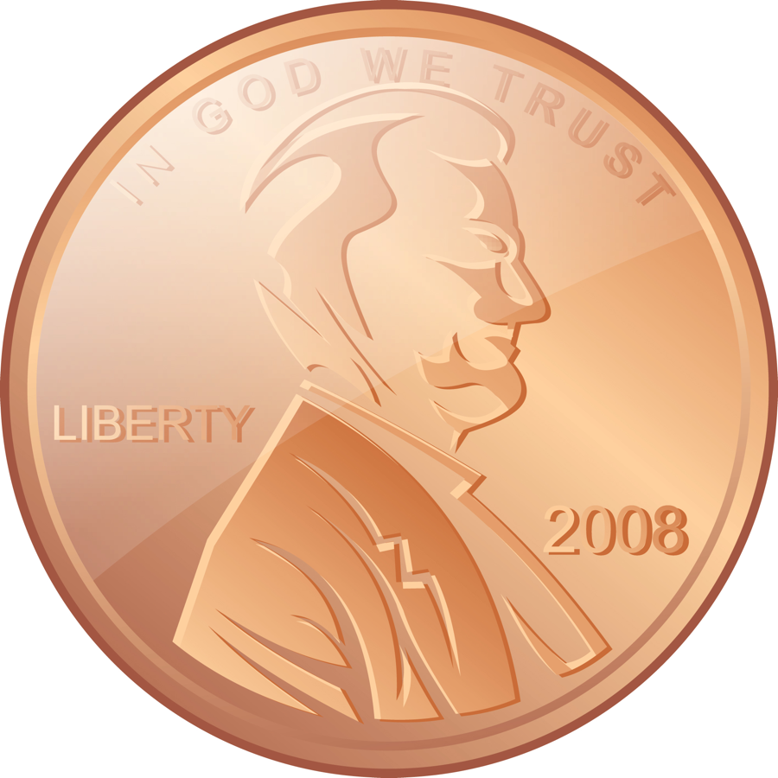
For example:


Weigh ten post-1982 pennies on the balance.

