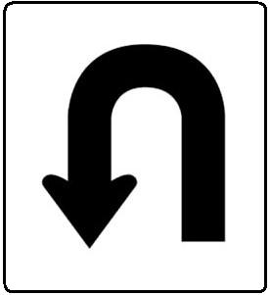

/50
Name Period Seat #

Tootsie Rolls, Pennies, and Blocks, Oh My!
PURPOSE:
The purpose of this lab is to discover different ways to calculate density in the laboratory, as well as to determine if density does, or does not, change based on the identity and/or shape of the material.
HYPOTHESIS: - what do you expect & why. Does NOT need to be an “if then” statement!

EQUIPMENT and MATERIALS:
Pennies (10 pre-1982 & 10 post-1982) Large & small Tootsie Rolls Ruler
Graduated Cylinder (100mL) Water Blocks

PROCEDURES: - record any data you take in the table below!!!!
- Using the items on your table, calculate the density of the each block. Do NOT get them wet!
- Using the items on your table, calculate the density of the tootsie rolls. Do NOT use a ruler!
- Using the items on your table, calculate the density of the pennies.
MAKE SURE TO KEEP THE PRE-1982 & POST-1982 PENNIES SEPARATE!

OBSERVATIONS/DATA:
GOLD COLORED Block | SILVER COLORED Block
SMALL Tootsie Rolls | LARGE Tootsie Rolls
PRE-1982 Pennies | POST-1982 Pennies

CALCULATIONS: (SHOW ALL WORK!!!)
GOLD COLORED Block | SILVER COLORED Block
SMALL Tootsie Rolls | LARGE Tootsie Rolls
PRE-1982 Pennies | POST-1982 Pennies
ANALYSIS:
- What do you notice about the densities of the BLOCKS?

- What do you notice about the densities of the TOOTSIE ROLLS?

- What do you notice about the densities of the PENNIES?
CONCLUSION: - You are writing the paragraph(s) AS A LAB GROUP AND WILL BE PROVIDING FEEDBACK ABOUT YOUR GROUP MEMBERS’ CONTRIBUTIONS. Print one copy of the paragraph, staple all the lab handouts together and staple the paragraph to the back of the packet.
- Restate the purpose of the lab
- Describe how you calculated the density of the objects
- State what your results were
- Were any results surprising? What did you learn about in class that would explain them?
- Explain how the lab related to the purpose – connect your results to the questions the purpose asked
- Was your hypothesis correct? Incorrect? A little of both? Explain.
- What were the sources of error? (DO NOT SAY “Human error”, and DO NOT list every single error that could ever possibly happen…just what might have actually happened in your lab
- How could the lab be extended or improved?

