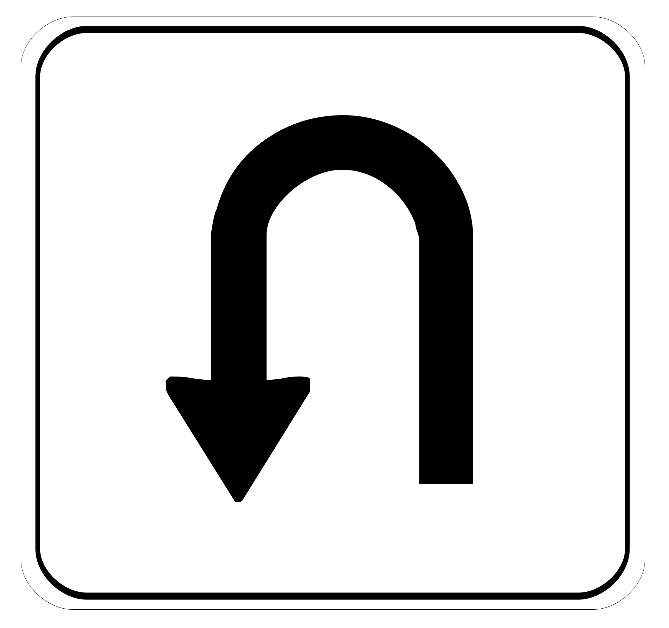

***“U Turn this in before you glue it in!”***

|  |  |
| --- | --- |
| Name: | |
| Period: | Seat #: |

MEASUREMENT ACTIVITY

Pre-Activity Questions

*You must complete these questions as homework in order to participate in the activity.*

|  |  |  |  |
| --- | --- | --- | --- |
| **1** | Google the term “beral pipette.” Sketch a picture of one, and describe what it is used for. | **2** | Google the term “graduated cylinder.” Sketch a picture of one, and describe what it is used for. |
| **3** | Google the term “how to read a graduated cylinder.” Why do you always need to read it from eye level? Sketch a picture to help you explain why. | **4** | What does it mean to “find the volume using  displacement?” Sketch a picture to help you explain this. |
| **5** | We often use Celsius to measure temperature in science. Sometimes we use another unit called “Kelvin.” What is the equation you use to convert from Celsius to Kelvin? | **6** | What is the equation to calculate density? List what each variable in the equation stands for. |

In Class Tasks

*You will be graded on how well you follow the instructions, showing your work for any and all math calculations, including UNITS on your measurements, in your work, and on your final answer, as well as cleaning up the lab supplies and equipment when finished. If you have questions it is your responsibility to ask!*

|  |  |
| --- | --- |
| Task #1 *Use the pipette to add 60 drops of water to the graduated cylinder. Make sure to read the cylinder from eye level when taking your measurement.*  Record the measurement in mL.  Convert to Liters. Show your work. | Task #2  *Use the balance to measure the mass of the metal cube. Be sure to use the zero function of the scale before you start measuring.*  Record the mass in grams.  Convert to mg. Show your work. |
| Task #3 *Fill the beaker with tap water. Measure the temperature. Make sure to wait a few minutes for the thermometer to accurately read the temp.*  Record the temperature in Celsius.  Convert to Kelvin. Show your work. | Task #4 *Have a partner say their ABCs out loud and record how long it takes to do so.*  Record the time it takes to say them in seconds.  Convert to milliseconds. Show your work. |
| Task #5 *Measure the length of the string.*  Record your answer in cm.  Convert to m. Show your work. | Task #6  *Calculate the density of the metal cube in g/cm3*  Record all the measurements taken.    Show your calculations and find your final answer. |
| Task #7  *Measure the volume of the irregularly shaped object.*  What technique did you use to accomplish this?  Record any measurements you needed to do this.  Show your calculations and find your final answer. | Task #8  *Measure the mass of 30mL of water. Use the “weigh boat” to help you. Dry it when done. Don’t forget to use the zero function of the scale before you start measuring.*  Record your answer in grams.  Convert to kg. Show your work.  Look up the density of water. Write it down here. |
| Task #9-A *Fill the graduated cylinder to 10mL. Add DROPS to the graduated cylinder using the pipette to raise the volume from 10mL to 13mL.*  Record the number of drops it takes you to do so.  *Using that number and your volume measurements on the graduated cylinder, calculate the number of “drops per mL” or “drops/1mL.” You are NOT counting how many drops per mL, you are calculating it based of the numbers you already have for Task 9.*  Show how you calculated this number. | |

Image result for winking smiley black and whiteLooking Forward *– This is a “sneak peek” at what we will be working on next. Watch the video and take enough notes so that I believe you actually watched it and learned from it* https://tinyurl.com/mtcaj3b

|  |
| --- |
|  |