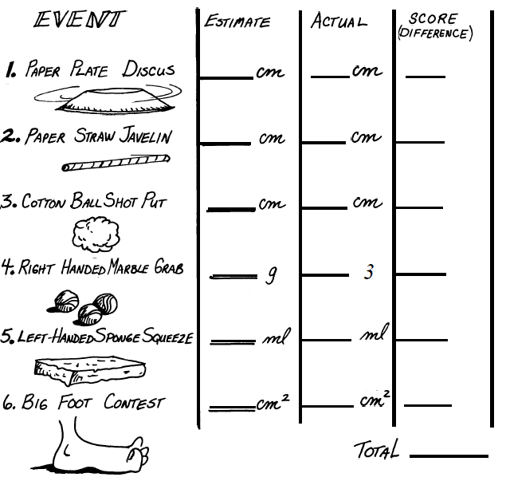

**Metric Olympics!**

* Follow the instructions on the lab benches
* Don’t forget about units!
* Make sure to clean your bench before moving on to the next bench.
* Winners come see Mrs. Farmer!

**(SMALLEST TOTAL WINS)**

|  |  |  |  |  |  |
| --- | --- | --- | --- | --- | --- |
| **% ERROR = (ERROR)/(ACTUAL) X 100** | | | | | |
|  | **EVENT** | **ESTIMATE** | **ACTUAL** | **ERROR** | **% ERROR** |
| **Length** (cm) | Hand |  |  |  |  |
| Arm Span (tip to tip) |  |  |  |  |
| **Weight** (g) | Pencil |  |  |  |  |
| Personal Item (free choice) |  |  |  |  |
| Cell Phone |  |  |  |  |
| **Volume** (mL or cm 3) | Block of wood |  |  |  |  |
| Paper Cup |  |  |  |  |
| **Area**  (cm 2) | Sheet of Paper |  |  |  |  |
| Desk top |  |  |  |  |
| Football field |  |  |  |  |
| **TOTAL POINTS = SUM OF % ERROR NUMBERS  (SMALLEST SCORE WINS)** | | | | |  |