How to Set Up Your Notes Page

Take notes on the left column, and draw visuals to represent the signs of a chemical reaction on the right column. Make sure to include color annotations!

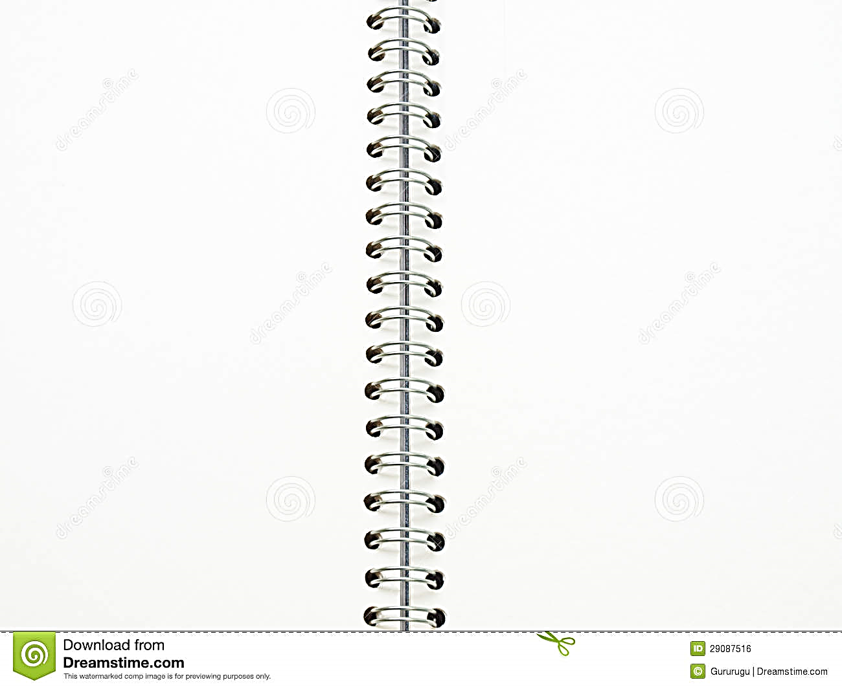

**Target: I can identify the signs of a chemical reaction**

**K**

**C**

**Q**

**Notes**

**Visuals**

Signs of a Chemical Reaction   
by David Chandler, eHow Contributor

Chemical reactions involve the rearrangement of atoms within molecules to produce new compounds. As the atoms of a compound are rearranged in a chemical reaction, energy is released and absorbed as bonds are created and broken, resulting in a net change of energy.

**Sign #1** – Temperature change

One form of the energy released or absorbed in a chemical reaction is heat. Exothermic reactions release heat energy (raise temperature) whereas endothermic reactions absorb heat (lower temperature).

**Sign # 2** – Light

Light is another form of energy. Some energy released in a chemical reaction may take the form of light. If it is the right amount of energy you may see it as colored light.

**Sign #3** – Gas is formed

The appearance of gas bubbles may indicate a chemical change when a product of the reaction is released as a gas. Note, though, that gas bubbles also form at the boiling point of a substance, which is not a chemical change.

**Sign #4** – Precipitate is formed

In solutions, a reaction may result in the appearance of a precipitate, an insoluble material that appears in a liquid. Freezing a liquid into a solid, though, is not a chemical reaction.

**Sign #5** – Color change

Many reactions will produce a color change in the reactants. This color change indicates the occurrence of a chemical reaction. Sometimes the reactants will go from clear to colored, or colored to clear.