Classification of Types of Matter

Matter is anything that takes up space and has mass. Things like thoughts, feelings, and ideas are “real” but they don’t have mass or take up space so they are not classified as matter. This is a very broad category so it is helpful to break it up into smaller, more specific categories. This activity will help you develop visual models of the more specific classifications of matter.

Directions

1. You will be working as a group to learn about the types of matter, make visual models of the different types of matter, and then do follow up questions to ensure that you learned what you were supposed to from the activity.
2. Please do not mix the playdough colors together! Please make sure the playdough lids are on tight when done! Playdough costs more than you would think when you have 165+ students! ☺
3. You will need to take apart all your models at the end of the period so that the next period doesn’t see all the answers!
4. Each type of matter will have its own set of instructions. Read them carefully and complete them in order.
5. There will be a quiz on this material so make sure you are focusing on the content and information, and not just playing with playdough ☺ Focus on the purpose of the lesson!
6. If you have questions – ask!
7. If you do not finish in class you will have to finish at home! Work quickly and efficiently to lessen your homework!

YOU SHOULD HAVE:

* Supplies:
  + Three different colors of playdough
    - The instructions will use orange, green and pink, but you may have different colors.
  + Box of toothpicks
* Laminated sheet for putting your models on
* Packet of instructions (this packet)
* Packet of reading notes
* Scratch paper for answering practice questions at the end.

Please note – colors of playdough may vary depending on what is available at the store each year ☺ As long as your key matches what you have that is fine!

**Directions for Elements Section**

1. Divide both your notes page and your drawing page into four sections. Label the sections Elements, Molecules, Compounds, and Mixtures.
2. Playdough = atoms  
   Toothpicks = bonds between atoms.
3. Each element is color coded. Same colors for each section.   
   Oxygen = orange Carbon = green Hydrogen = pink
4. Read: about Elements on the notes page.
5. Take Notes: in the Element notes box, summarize what an element is.
6. Playdough Model: the various elements – oxygen, carbon, and hydrogen. This should be very easy! Ha! ☺
7. Check: have your teacher check your model.
8. Sketch and Label: in the Element drawing box. Under each drawing, label it with its element name.

**Directions for Molecules Section**

1. Read: about Molecules on the notes page.
2. Take Notes: in the Molecules notes box, summarize what a molecule is.
3. Playdough Model: create a diatomic Hydrogen molecule (H2) - when one hydrogen atom bonds to another hydrogen atom.

* Take a ball of pink playdough and connect it to another ball of pink   
  playdough with a toothpick.

1. Check: have your teacher check your model.
2. Sketch and Label: in the Molecule drawing box. Label it “Diatomic Hydrogen (H2).”
3. Playdough Model: create a diatomic Oxygen molecule (O2) – when one oxygen atom bonds to another oxygen atom. In order for Oxygen to form a stable molecule it needs to be formed with a double bond. This allows each oxygen molecule to have a stable outer shell of electrons.

* Take an orange ball of playdough and connect it to another orange ball of playdough with **two** toothpicks to show the double bond.

1. Check: have your teacher check your model.
2. Sketch and Label: in the Molecule drawing box. Label it “Diatomic Oxygen (O2).”
3. Playdough Model: create a Water molecule (H2O) – when one oxygen atom bonds with 2 hydrogen atoms. As you read in the notes page, a water molecule is in the shape of a triangle with the oxygen in between the hydrogen molecules.

* Take an orange ball of playdough and stick a pink ball of playdough onto one side of the orange ball with a toothpick. Now stick another pink ball of playdough to the orange ball using a toothpick - make sure it forms a triangle shape. Important: There should ***not*** be a toothpick that connects the two pink playdough balls!

1. Check: have your teacher check your model.
2. Sketch and Label: in the Molecule drawing box. Label this molecule “Water (H2O).”

**Directions for Compounds Section**

1. Read: about Compounds on the notes page.
2. Take Notes: in the Compounds notes box, summarize what a Compound is.
3. Playdough Model: create another Water molecule (H2O). Remember, all compounds are also molecules! So, water can be located in both the Molecule and the Compound sections!
4. Check: have your teacher check your model.
5. Sketch and Label: in the Compound drawing box. Label this compound “Water (H2O).”
6. Playdough Model: create a carbon dioxide (CO2) molecule – when a carbon atom is double bonded to two oxygen atoms.

* Take a green ball of playdough and stick two toothpicks to connect it to an orange ball of playdough. Repeat on the opposite side. This molecule should have playdough balls all in a straight line. This is called a linear molecule. CO2 forms double bonds to help all atoms have a stable outer electron shell.

1. Check: have your teacher check your model.
2. Sketch and Label: in the Compound drawing box.   
   Label this compound “Carbon Dioxide (CO2).”
3. Playdough Model: create a methane (CH4) molecule – when one carbon atom bonds to four hydrogen atoms. The key is that the carbon is connected to each of the hydrogen atoms. Hydrogen is only allowed to form one bond because it is so small, so it has no choice but to always go on the outside!

* Take a green ball of playdough and   
  stick four toothpicks into it (one on each side).   
  It should look like an x or a + sign. Then, stick   
  a pink ball of playdough on the end of   
  each of the toothpicks.

1. Check: have your teacher check your model.
2. Sketch and Label: in the Compound drawing box.   
   Label this compound “Methane (CH4).”

**Mixtures**

1. Read: the Mixtures section on the notes page.
2. Take Notes: in the Mixtures notes box, summarize what a Mixture is, and what the two types of mixtures are.
3. Playdough Model: create carbonated water (like soda water!). Carbonated water occurs when carbon dioxide dissolves in water. These molecules mix, but to not bond together with ionic or covalent bonds.

* Take your carbon dioxide molecule and your water molecule and simply sit them next to each other. Do not add a toothpick that connects them!

1. Check: have your teacher check your model.
2. Sketch and Label: in the Mixture drawing box. Label this mixture “Carbonated Water”.

Notes on Elements

* Pure elements are made up of all 1 kind of atom.
* Every atom will have the same number of protons.
* The atoms in an element are NOT bonded to one another.
* Notice the 2nd picture, there are a bunch of identical atoms just sitting next to each other.
* Elements have atoms that are chemically the same. It is the smallest sized unit that will have the chemical behaviors associated with that element. It will “behave” like itself.

**An element: An element:**

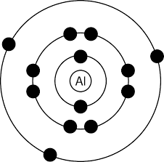Single Aluminum Atom Many of the same   
 type of Atoms next   
 to each other

Notes on Molecules

Molecule: more than one atom bonded together

Elements bond together when they share or transfer their outer shell electrons (called valence electrons). There are many ways that a molecule can be shown.   
Below are a few examples.

* Sometimes molecules are shown by showing where their outer electron layers are overlapping. (the first picture of oxygen and ozone)
* Sometimes molecules are shown by drawing them as balls stuck together. (the second picture of oxygen and ozone)
* Sometimes molecules are shown by drawing them as balls connected by sticks. The balls are the molecules and the sticks are the bonds holding them together. (the third picture of O2 and O3)
* Notice how in both examples, there is more than one atom that is connected in some way. This is different than the element that did not have the atoms connected.

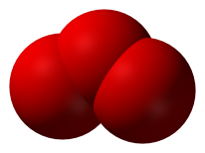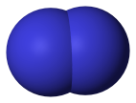**Oxygen (O2) Ozone (O3)**

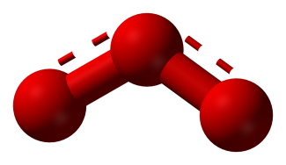

**Oxygen**

**Oxygen**

**Oxygen**

**Oxygen**

**Oxygen**

**Molecule Notes   
continued on next   
page!**

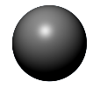

Molecules can have more than one type of element.

Sugar (C6H12O6)

* Glucose has carbon, hydrogen, and oxygen atoms bonded together. Because there is more than one atom bonded together, it is a molecule. Molecules can be made up of more than one of the same kind of element like O2 gas is, or of several different kinds of elements like sugar is.
* You can tell there are more than one type of element because there is more than one chemical symbol (C, H, and O). Each chemical symbol represents a different element.
* You can also often tell there are different elements because the color or shading of the “balls” are different to show they are different kinds of atoms.
* The small numbers are called subscripts. These tell how many atoms of each element are bonded together. In C6H12O6, there are 6 C’s (carbon atoms), 12 H’s (hydrogen atoms), and 6 O’s (oxygen atoms).

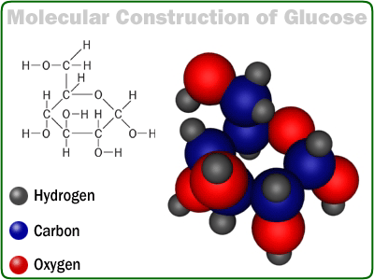

Notes on Compounds

Compounds: More than one *different* elements bonded together.

* Water, H2O, has two hydrogen and one oxygen atom. It is important to draw it in a triangle shape. There are extra electrons on the oxygen called “lone pairs” that push the hydrogen down.
* You can tell it is a compound because there are two different chemical symbols (H and O).
* You can also tell it is a compound because there are two different colored/shaded balls that are connected by a bond.

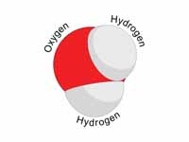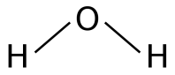**Water (H2O)**

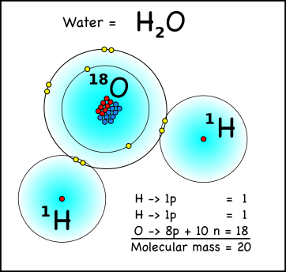

**Compound   
  
Notes continued on next   
page!**

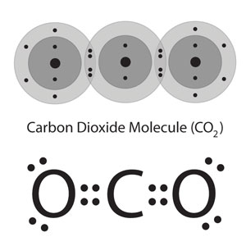**Carbon Dioxide (CO2)**

* Some compounds have double bonds. This means that there are more outer electrons being used to make the bond. The two lines between the oxygen and carbon atoms means carbon dioxide has a double bond. Two bonds mean there are four electrons being shared.
* Notice again that there are two different elements involved so it is a compound.

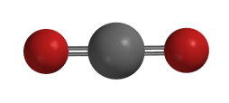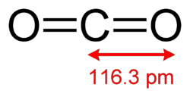

* A salt is a kind of compound. We are familiar with table salt, but there are many kinds of salts.
* Notice again that there are two different kinds of elements, Na and Cl. This makes it a compound.

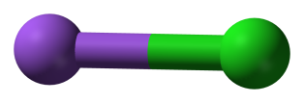**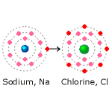Sodium Chloride or Salt (NaCl)**

Na Cl

All compounds are also molecules! (But not all molecules are compounds.)

* Carbon dioxide (CO2) is a molecule and a compound.
* Because there is more than one atom bonded together it is a molecule.

Because the two atoms are different types of elements (notice the shading of the balls is different), it is also a compound.

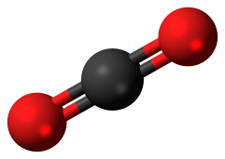

* Oxygen (O2) is a molecule. It is not a compound.
* Because there is more than one atom bonded together it is a molecule.

Because the two atoms are the same type of element (notice the shading of the balls is the same), it cannot be a compound.



Notes on Mixtures

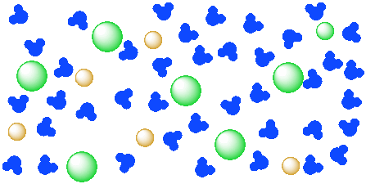Mixtures: A mix of elements, compounds and/or molecules that can be separated by physical means (By sifting/straining, magnets,   
dissolving, evaporating, etc) Pure elements/compounds/mixtures cannot be separated with physical means, they have to be pulled apart with chemical means in a chemical reaction. Since mixtures have items with different properties from each other, you can use those different properties to physically separate them from each other.   
 **Compound   
Notes continued on next**

**page!   
 Salt Water (NaCl dissolved in H2O)**

* Mixtures have multiple elements, compounds and/or molecules that are mixed together, but not bonded together.
* Notice that in the picture of salt water there are salt molecules and water molecules but they are not connected together with ionic or covalent bonds.
* Salt water is a solution. It has one thing dissolved into another.
* Example Solutions: kool aid, salt water, air, brass, 14 carat gold, soda
  + *Solute - the “thing” that gets dissolved*
  + *Solvent – the “thing” that does the dissolving*
  + *Solute - the thing that gets dissolved*
  + *Solvent – the thing that does the dissolving*

**There are two types of mixtures.**

Heterogeneous: mixtures that are not the same throughout

Examples: pizza, cookie dough, chex mix, Italian dressing

Homogeneous: mixture that is the same throughout

Examples: air, tree sap, Mountain Dew, tap water

**Oxygen, Oxygen, and Air**

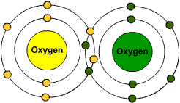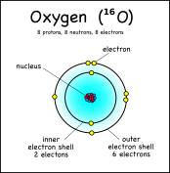

Atmosphere (Air) Gas Mixture

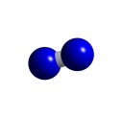

Nitrogen 78%



Oxygen 21%

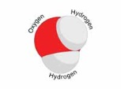

Water Vapor <1%

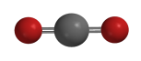

Carbon Dioxide <1%



Helium <1%



Neon <1%



Argon <1%

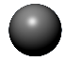

Krypton <1%

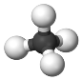

Methane <1%

This is oxygen the element. It is not bonded or mixed with any other atoms.

This is oxygen (O2) the molecule. It is bonded with another oxygen atom. This is the oxygen we breathe. This is the oxygen that we use during cellular respiration and that plants produce during photosynthesis.

Air is a mixture. There are many molecules mixed together but not bonded together. Notice that Oxygen (O2) is one of these molecules but it is not the only molecule in air. IMPORTANT: Oxygen is NOT air!!!! It is just one of many things that is inside what we call “air.”

Check your understanding!

True or False. Answer these questions as a group. You can use scratch paper to keep track of your answers. You do not need to keep your scratch paper when finished. Check your answers on the back! Don’t peek at the answers ahead of time! ☺

1. Oxygen (O2) is a mixture.
2. Air is a molecule.
3. An element is made out of only one   
   kind of atom.
4. The atoms in a pure element are not   
   bonded together.
5. The atoms in a molecule are not bonded together.
6. When looking at drawings of a molecule, the “spheres” often represent molecules, & lines or sticks represent the bonds connecting them.
7. A molecule could be made of the same atoms or different atoms that are bonded together.
8. Ozone (O3) is made of three oxygen atoms and is a compound.
9. Water, salt and carbon dioxide are molecules.
10. Water, salt, and carbon dioxide are all compounds.
11. NaCl is made out of four different kinds of atoms.
12. H2O2 is made up of 2 hydrogen atoms and 2 oxygen atoms.
13. Ammonia (NH3) is a compound.
14. A water molecule is in the shape of a triangle.
15. A carbon dioxide molecule has a single bond.
16. Bonds are formed when the electrons in the outer shell are shared or transferred.
17. Atoms are the building blocks of elements, molecules, compounds, and mixtures.
18. Sodium Chloride, or table salt, is a compound.
19. Air is a mixture of many different gas molecules.
20. Pizza is a heterogeneous mixture.
21. Salt water is a heterogeneous mixture.
22. A solution is when one substance dissolves in another.
23. In Kool Aid, water is the solute.
24. In Kool Aid, the sugar is the solute.
25. Another word for air is oxygen.
26. Often when you look at the drawing of a compound, you will notice that there are different colored “spheres” bonded together.
27. Tap water has many things dissolved in water. This means that tap water is a homogeneous mixture.
28. Solutions are homogeneous mixtures.
29. Pure water (H2O) is a compound and a molecule.

*Answers are on the back!*

1. FALSE – Oxygen is a molecule
2. FALSE - Air is a mixture
3. TRUE
4. TRUE
5. FALSE – The atoms in a molecule are bonded together
6. FALSE – When looking at drawings of a molecule, the “spheres” often represent elements or atoms and the sticks represent the bonds connecting them.
7. TRUE
8. FALSE – Ozone (O3) is made of three oxygen atoms and is a molecule.
9. TRUE
10. TRUE
11. FALSE – NaCl is made out of two different kinds of atoms.
12. TRUE
13. TRUE
14. TRUE
15. FALSE – A carbon dioxide molecule has a double bond.
16. TRUE
17. TRUE
18. TRUE
19. TRUE
20. TRUE
21. FALSE – Salt water is a homogeneous mixture.
22. TRUE
23. FALSE – In Kool Aid, water is the solvent.
24. TRUE
25. FALSE – Another word for O2 is oxygen.
26. TRUE
27. TRUE
28. TRUE
29. TRUE