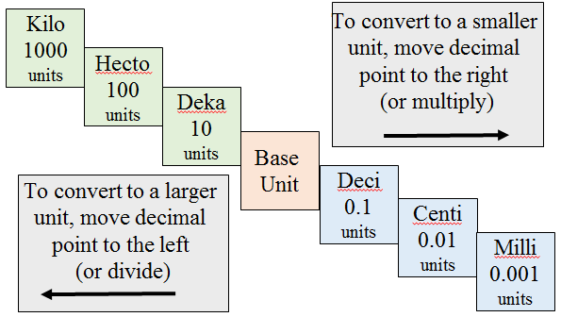  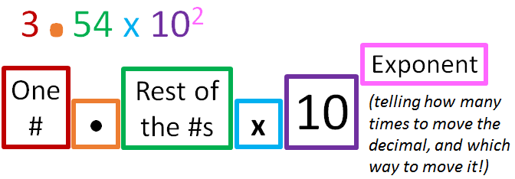 | Convert to new unit
 | #1 | 27500 mg g
 | #2 | 0.15 DL mL
 | Convert into Std. Form
 | #3 | 1.0 x 10¹
 | #4 | 1.0 x 10⁰
 | #5 | 1.0 x 10⁻¹
 | #6 | 2.5 x 10⁴
 | #7 | 3.8 x 10⁻²
 | Convert into Sci. Not.
 | #8 | 541
 | #9 | 9.5
 | #10 | 0.025

 | Convert to new unit
 | #1 | 27500 mg g
 | #2 | 0.15 DL mL
 | Convert into Std. Form
 | #3 | 1.0 x 10¹
 | #4 | 1.0 x 10⁰
 | #5 | 1.0 x 10⁻¹
 | #6 | 2.5 x 10⁴
 | #7 | 3.8 x 10⁻²
 | Convert into Sci. Not.
 | #8 | 541
 | #9 | 9.5
 | #10 | 0.025

 | Convert to new unit
 | #1 | 27500 mg g
 | #2 | 0.15 DL mL
 | Convert into Std. Form
 | #3 | 1.0 x 10¹
 | #4 | 1.0 x 10⁰
 | #5 | 1.0 x 10⁻¹
 | #6 | 2.5 x 10⁴
 | #7 | 3.8 x 10⁻²
 | Convert into Sci. Not.
 | #8 | 541
 | #9 | 9.5
 | #10 | 0.025
 | Convert to new unit
 | #1 | 27500 mg g
 | #2 | 0.15 DL mL
 | Convert into Std. Form
 | #3 | 1.0 x 10¹
 | #4 | 1.0 x 10⁰
 | #5 | 1.0 x 10⁻¹
 | #6 | 2.5 x 10⁴
 | #7 | 3.8 x 10⁻²
 | Convert into Sci. Not.
 | #8 | 541
 | #9 | 9.5
 | #10 | 0.025

 | Convert to new unit
 | #1 | 27500 mg g
 | #2 | 0.15 DL mL
 | Convert into Std. Form
 | #3 | 1.0 x 10¹
 | #4 | 1.0 x 10⁰
 | #5 | 1.0 x 10⁻¹
 | #6 | 2.5 x 10⁴
 | #7 | 3.8 x 10⁻²
 | Convert into Sci. Not.
 | #8 | 541
 | #9 | 9.5
 | #10 | 0.025

 | Convert to new unit
 | #1 | 27500 mg g
 | #2 | 0.15 DL mL
 | Convert into Std. Form
 | #3 | 1.0 x 10¹
 | #4 | 1.0 x 10⁰
 | #5 | 1.0 x 10⁻¹
 | #6 | 2.5 x 10⁴
 | #7 | 3.8 x 10⁻²
 | Convert into Sci. Not.
 | #8 | 541
 | #9 | 9.5
 | #10 | 0.025

