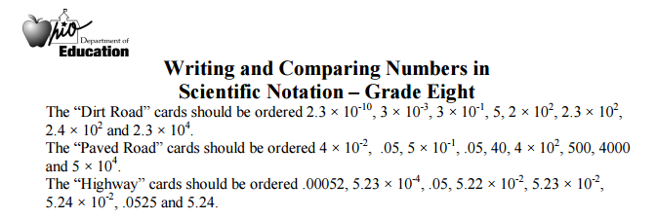

<https://www.teacherspayteachers.com/Product/8th-Grade-Scientific-Notation-Activity-Maze-2078974>

https://dpsmsmath.wikispaces.com/file/view/1.06-scientificsquare.pdf