1. **Paper Set Up** – Divided into four boxes. Label each box – Game 1, Game 2, Game 3, Game 4. Number each box #1-5 because each game has five questions. Don’t forget target at the top, you do not need KCQ boxes this time! This is the only work going on this page, so use the entire sheet of binder paper! Don’t squish your work into tiny little boxes!

|  |  |
| --- | --- |
| Game 1 | Game 2 |
| Game 3 | Game 4 |

1. **Go to this website:**   
   <https://games.legendsoflearning.com/games/WyJnYW1lcyIsMTM3OF0=>

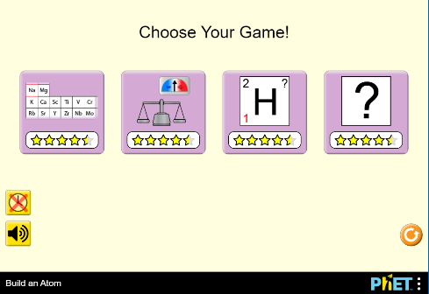

This is what the various parts of the game represent. This will be true for all games – red circles are always the protons, blue are electrons, etc.

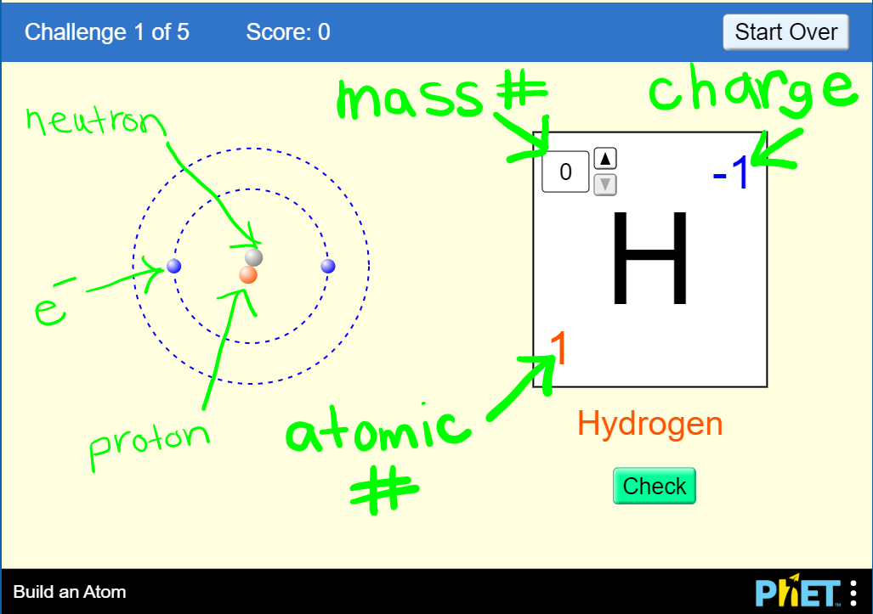

**NOTE:** The following screen shots of each game may look a little different than what you see, it scrambles questions and gives slightly different ones each time, but it should be relatively similar.

1. 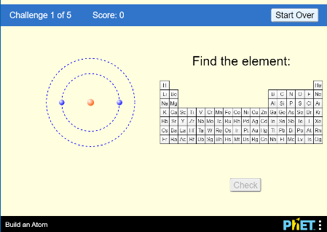**Game 1 -** You will do all four games. Start with the one on the left, moving to the right each time. There are 5 questions for each game. Record the work/answer for each question in your notebook. Use a periodic table to help you answer the questions.
2. 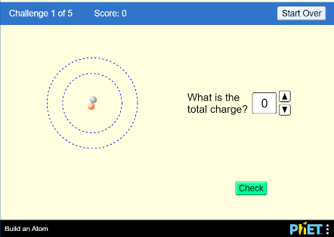**Game 2** – There are five Qs. Record work/answers in the second box on your notebook paper.
3. **Game 3** - There are five Qs. Record work/answers in the second box on your notebook paper.

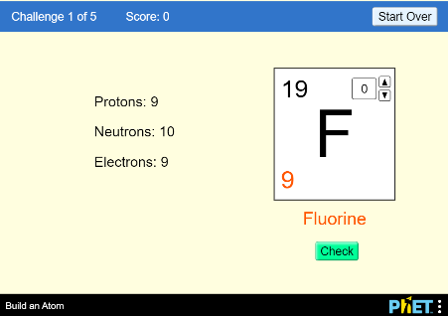

1. 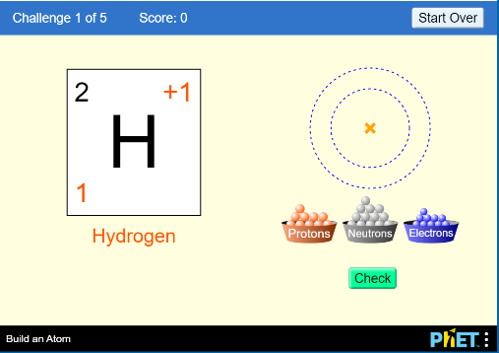 **Game 4** - There are five Qs. Record work/answers in the second box on your notebook paper.

1. **Check your learning** – Use the following game to see how you did learning this topic You do not have to record anything in your notebook, just take ownership of your learning and check to see how you are doing! ☺   
     
   <https://games.legendsoflearning.com/games/WyJnYW1lcyIsMTM3N10=>