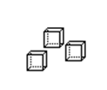  
  
  
  
  
  
  
  
  
  
  
  
  
  
  
  
  
  
  
  
  
  
  
  
  
  
  
  
  
  
  
  
  
  
  
  
  
  
  
  
  
  
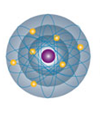  
  
  
  
  
  
  
  
  
  
  
  
  
  
  
  
  
  
  
  
  
  
  
  
  
  
  
  
  
  
  
  
  
  
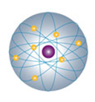  
  
  
  
  
  
  
  
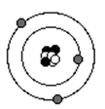  
  
  
  
  
  
  
  
  
  
  
  
  
  
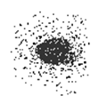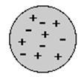  
  
  
  
  
  
  
  
  
  
  
  
  
  
  
  
  
  
  
  
  
  
  
  
  
  
  
  
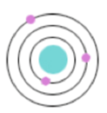  
  
  
  
  
  
  
  
  
  
  
  
  
  
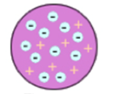  
  
  
  
  
  
  
  
  
  
  
  
  
  
  
  
  
  
  
  
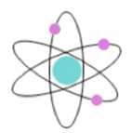  
  
  
  
  
  
  
  
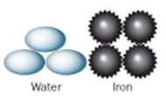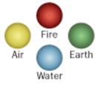  
  
  
  
  
  
  
  
  
  
  
  
  
  
  
  
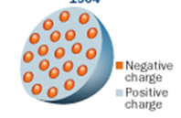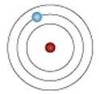  
  
  
  
  
  
  
  
  
  
  
  
  
  
  
  
  
  
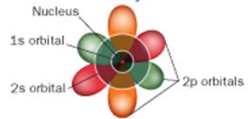

**Negatively charged electrons spread throughout a sphere of positive charge like chocolate chips spread through cookie dough.**

**Atoms are simple building blocks and are made up of pieces of the elements – earth, air, fire and water.**

**Dense, positively charged nucleus, containing nearly all the atom’s mass, surrounded by electrons only allowed to travel in specific orbits in allowed energy levels.**

**Atoms are made up of small objects that are different shapes and sizes and colors depending on the material they make up. For example – solids are small and pointy objects, and liquids are large round or smooth objects.**

**Electrons travel not in orbits, but exist as clouds of electric charge within “orbitals” that define regions of space with a high probability of containing the electron. These orbitals are defined by complex mathematical equations and have complex shapes**

**Atoms are eternally unchanging and indivisible spherical objects like billiard balls.**

**Positive charge located within a dense, positively charged nucleus, containing nearly all the atom’s mas. Negative electrons travel around the outside like planets traveling around the sun.**

