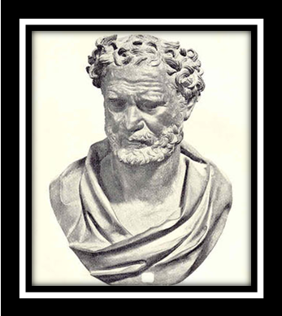
Democritus
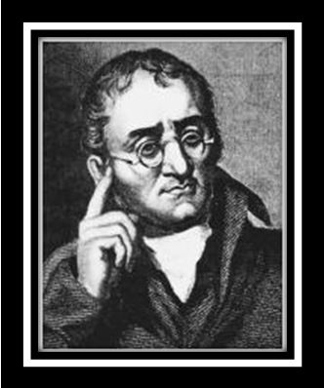
John Dalton
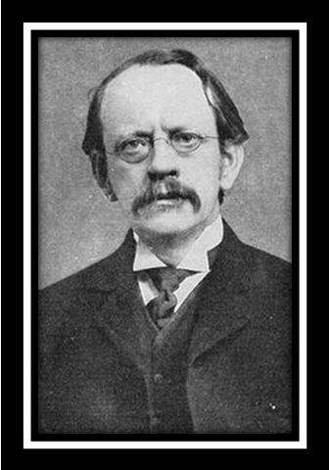
J.J. Thomson
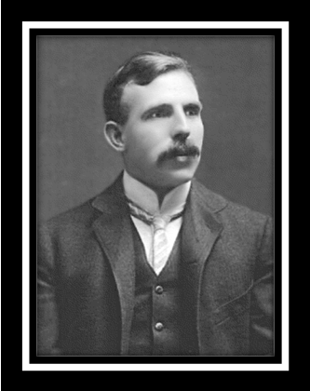
Ernest Rutherford
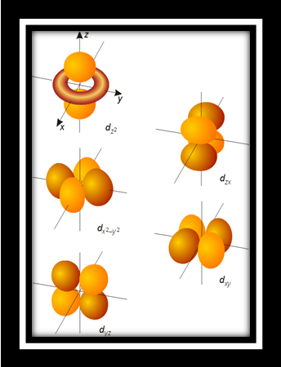
Orbitals
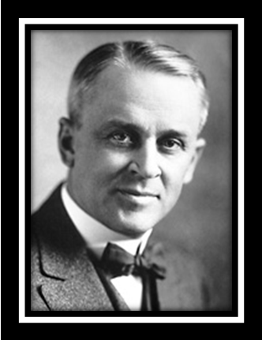
Robert Milikan
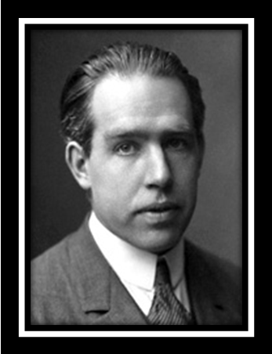
Niels Bohr
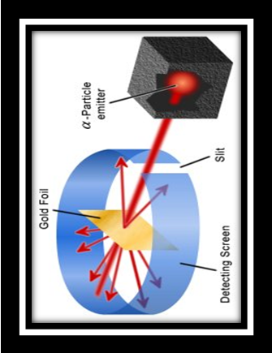
Gold Foil Experiment

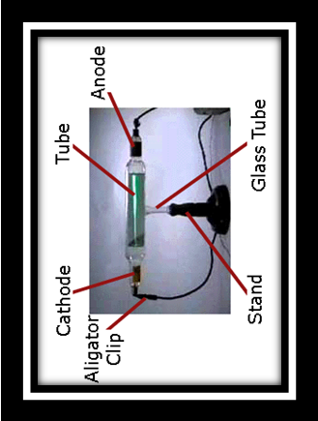
Cathode Ray Tube Experiment
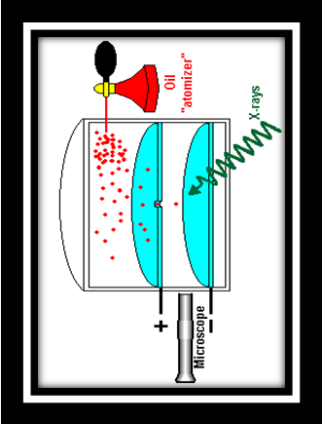
Oil Drop Experiment
Cathode Ray Tube Experiment
Oil Drop Experiment
Cathode Ray Tube Experiment
Oil Drop Experiment
Cathode Ray Tube Experiment
Oil Drop Experiment

