Visualizing Orbitals Practice

* Please set up your paper like this. Use the entire paper! Big boxes that take up the entire page please!

|  |  |  |
| --- | --- | --- |
| 1 - Hydrogen | 2 – Helium | 3 – Lithium |
| 4 – Beryllium | 5 – Boron | 6 – Carbon |
| 7 – Nitrogen | 8 – Oxygen | 9 – Fluorine |
| 10 – Neon | 11- Sodium | 12 - Magnesium |

* Please go to the following website

<http://www.johnmacneill.com/Atom_Table.html>

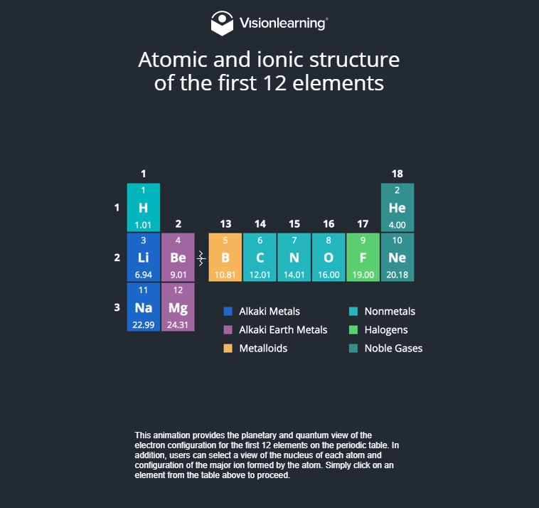

* You will need to click on each element to see an animation of what that element’s quantum orbitals look like.
* Sketch out what the Quantum Model orbitals look like. While it is interesting to see the Bohr Orbital Models at the top of the page, that isn’t what we are learning about right now! Make sure to sketch the Quantum models at the bottom of the page for each element. Pay attention to shape, size, location, and make sure to color code your sketches.

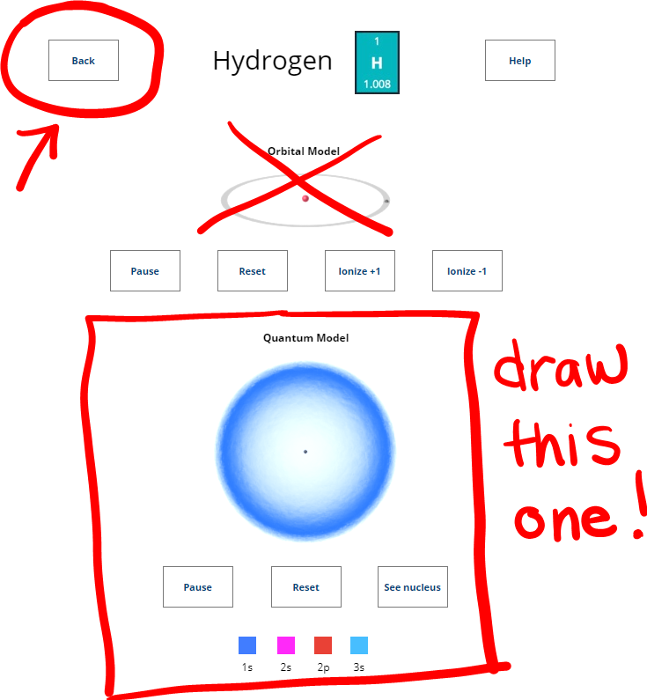

* When you are done, hit the “Back” button to go back to the main screen so you can click on the next element.
* I’ve noticed that this website takes a little while to load the animations the first time you click on each one, so be patient if needed. I checked my Instagram in between things loading – ha!