Glue this side down to your notebook

Where are those darn electrons?!

Instructions: Examine the dot-plots of electron orbitals below.
You will use these images to answer questions as you work through activity.
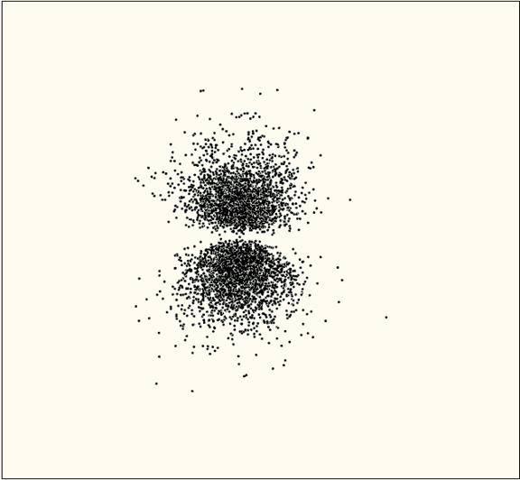
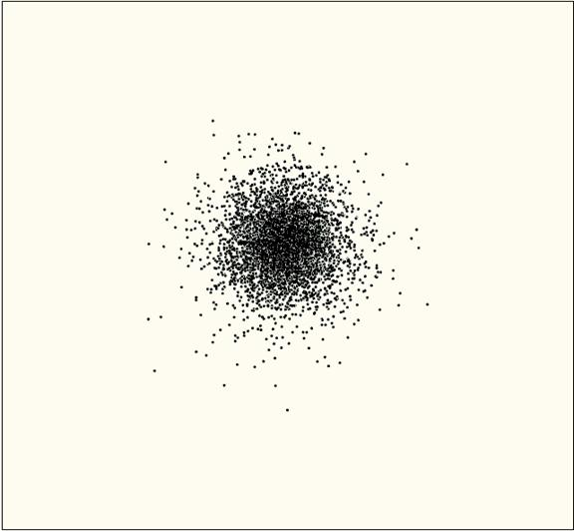
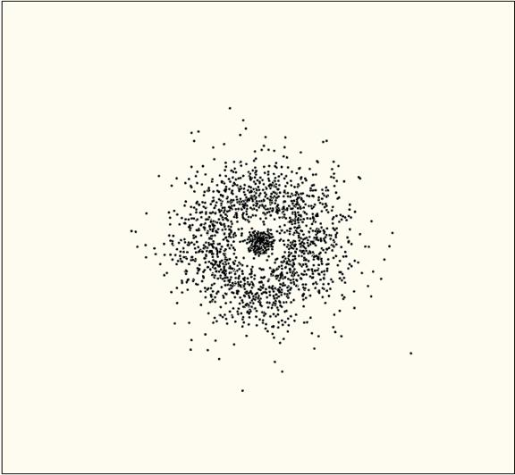

1s orbital 2s orbital 2p_{z} orbital

1) Describe the shape of the 1s orbital.

2) How does the shape of the 2s orbital compare to the 1s orbital?

3) Describe the shape of the 2p orbital shown here.

4) There are actually three 2p orbitals, spaced evenly around an atom’s nucleus (only ONE
is shown in the dot plot). See if you can draw the three 2p orbitals on the xyz plot below.

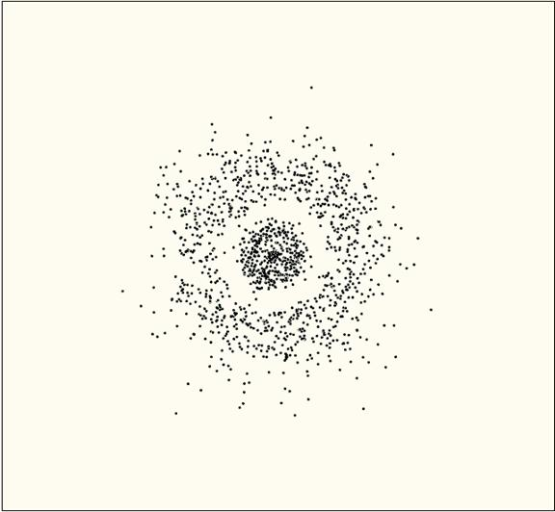
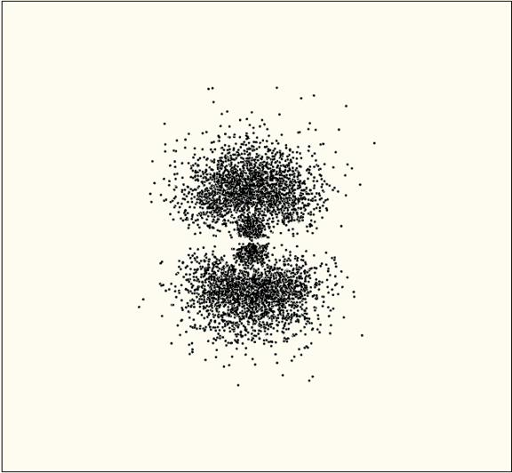

3s orbital 3p_{z} orbital

5) Compare the 3s orbital with the 1s and 2s orbitals. What do you notice about the number of ‘layers’ in the 3s orbital?

6) As the energy levels of orbitals get higher, their shapes get more complex. How does the 3p orbital shown differ from the 2p orbital?

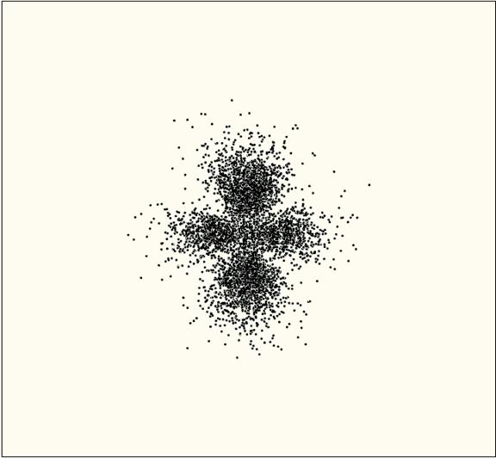
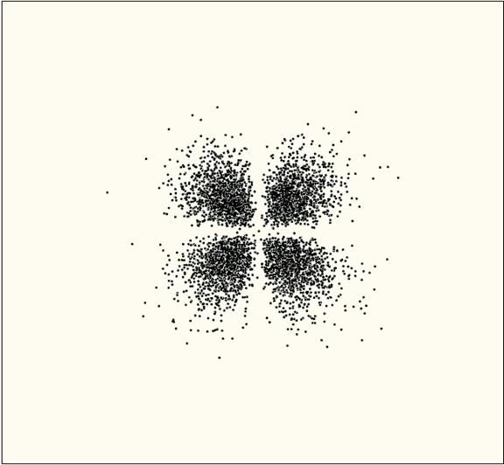

3d_{yz} orbital (4 have this shape) 3d_{z} orbital (1 has this shape)

Additional Information: Dot-plot images images of orbtials can be created using wave equations for electrons. Through some complicated mathematics, these equations show how likely it is to find an electron at a certain spot inside an atom. The points where an electron is found are marked by a dot – this creates a ‘density diagram’ for the electrons. In other words, we find the areas in atoms where there is a high probability of finding an electron. The orbitals are actually three-dimensional, but we usually look at cross-sections so that they are two-dimensional.

6) What does each ‘dot’ represent in the plots you have been looking at?

7) Write a 2-3 sentence summary of the ‘shapes’ of the orbitals.

8) Based on the diagrams for the 1s, 2s, and 3s orbitals, use the space below to draw a prediction for the dot plot diagram for the 4s orbital.

9) Based on the diagrams for the 2p and 3p orbitals, use the space below to draw a prediction for the dot plot diagram for a 4p orbital.

10) Write down at least two additional questions that you have.
a.

b.

