Dougherty Valley HS Chemistry Name:
Equilibrium Date:
Cartoon Period:

- Draw a “Far Side” Cartoon that describes something about equilibrium. One panel, and no more than two sentences of a caption.
- Must take up top two thirds of an entire 8 ½ x 11” piece of printer paper.
- On the bottom third of your cartoon explain what it shows about Equilibrium
- You must use at least 4 different colors!
- Points will be given based on effort, thought, and by how well it shows something about equilibrium. I know not everyone is an artist…but just try your best!

Try to make it funny and/or clever! The funniest/most unique one may get a prize ☺
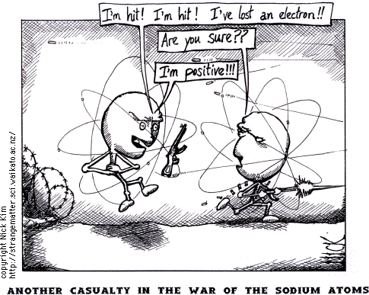
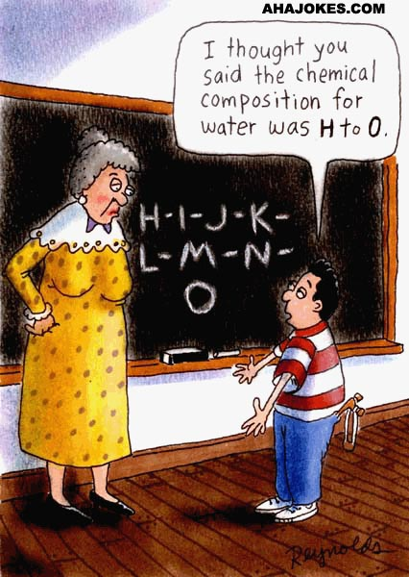
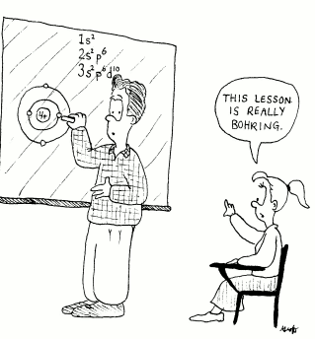

Dougherty Valley HS Chemistry Name:
Equilibrium Date:
Cartoon Period:

- Draw a “Far Side” Cartoon that describes something about equilibrium. One panel, and no more than two sentences of a caption.
- Must take up top two thirds of an entire 8 ½ x 11” piece of printer paper.
- On the bottom third of your cartoon explain what it shows about Equilibrium
- You must use at least 4 different colors!
- Points will be given based on effort, thought, and by how well it shows something about equilibrium. I know not everyone is an artist…but just try your best!

Try to make it funny and/or clever! The funniest/most unique one may get a prize ☺

