Le Chatelier’s Principle Worksheet #2
- In the following reaction, will the [H2] increase or decrease
when equilibrium is reestablished after these stresses
are applied?
N2(g) + 3 H2(g) ↔ 2 NH3(g) + 22 kJ

NH3(g) is added ________ N2(g) is removed ________
pressure is increased ________ Temperature is increased ________

- In which direction, left or right, will the equilibrium shift if the following
changes are made?
2 NO (g) + H2(g) ↔ N2O (g) + H2O (g) + 36 kJ

NO is added ________ The system is cooled ________
H2 is removed ________ Pressure is increased ________
N2O is added ________ H2 is added ________

3) In this reaction: CO2(g) + H2(g) + heat ↔ CO (g) + H2O (g)

Is heat absorbed or released by the forward reaction? ____________

In which direction will the equilibrium shift if these changes are made?

CO is added ________ Temperature is increased ________
CO2 is added ________ System is cooled ________
H2 is removed ________ Pressure is increased ________
Catalyst is added ________

4) In this reaction: 2 NO (g) + H2(g) ↔N2O (g) + H2O (g) + heat
What will happen to the [H2O] when equilibrium is reestablished after these
stresses are applied?

Temperature is increased ________
A catalyst is added ________
Pressure is decreased ________
NO is added ________
N2O is removed ________
p. 236

5) How would an increase in pressure affect the [H2] in the following reactions?
2 H2(g) + O2(g) ↔ 2 H2O (g) __________
4 H2(g) + Fe3O4(s) ↔ 3 Fe (s) + 4 H2O (l) __________
H2(g) + Cl2(g) ↔ 2 HCl (g) __________
6) State Le Chatelier’s Principle in your own words.

7) The reaction of iron(III) oxide with carbon monoxide occurs in a blast furnace
when iron ore it reduced to iron metal:
Fe2O3 (s) + 3 CO (g) ↔ 2 Fe (l) + 3 CO2 (g)
Use Le Chatelier’s Principle to predict the direction of reaction when an
equilibrium mixture is disturbed by :
Adding CO (g) __________ Removing CO2 (g) __________
Adding Fe2O3 (s) __________
8) For the reaction, PCl5 (g) ↔ PCl3 (g) + Cl2 (g) ΔHrxn = +111 kJ.
Fill in the following table.

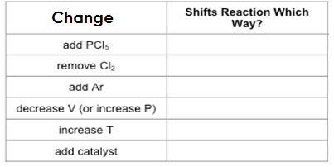
9) For the reaction: 2HI(g)↔H2(g) + I2(g) ΔHrxn = -51.8kJ
Fill in the following table:
