Name:
Period: Seat #:

Half-Life Worksheet L

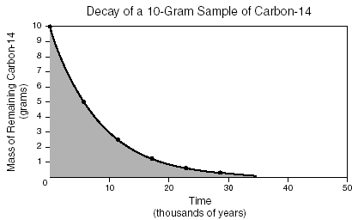

1. According to the graph, what is the approximate half-life of carbon-14?
A. 5.7 years B. 5,700 years
C. 23,000 years D. 1,000,000 years

- What is half-life?

- What type of Carbon in used in Carbon dating?

- If you have 200 grams of radioactive Polonium with a half life of 50 years. How much is left after 50 years?

  - How much is left after 100 years?

  - How much is left after 150 years?

Name:
Period: Seat #:

Half-Life Worksheet L

1. According to the graph, what is the approximate half-life of carbon-14?
A. 5.7 years B. 5,700 years
C. 23,000 years D. 1,000,000 years

- What is half-life?

- What type of Carbon in used in Carbon dating?

- If you have 200 grams of radioactive Polonium with a half life of 50 years. How much is left after 50 years?

  - How much is left after 100 years?

  - How much is left after 150 years?

  - How many half lives did it take to get to 50 grams?

- What are the three types of nuclear decay?

- What can each type of nuclear decay be stopped by?

- The half-life of radium-222 is 38 seconds. If you had a 12 gram sample, how much would be left after
76 seconds? _____ 114 seconds?_____

- Sodium 24 has a half-life of 10 hours. You begin with a sample of 50 grams. It begins to decay. How much Sodium-24 would you have after 10 hours? ____
30 hours? ____
50 hours? ____

- What trend do you notice in the following graph?
  - How many half lives did it take to get to 50 grams?

- What are the three types of nuclear decay?

- What can each type of nuclear decay be stopped by?

- The half-life of radium-222 is 38 seconds. If you had a 12 gram sample, how much would be left after
76 seconds? _____ 114 seconds?_____

- Sodium 24 has a half-life of 10 hours. You begin with a sample of 50 grams. It begins to decay. How much Sodium-24 would you have after 10 hours? ____
30 hours? ____
50 hours? ____

- What trend do you notice in the following graph?

