1. Which particles make up the nucleus?
2. Why do we say that the mass of an atom is in the nucleus?
3. Copy the chart Mrs. Farmer projects on the board - fill in the info that is missing:
4. Complete the nuclear rxns below. Question Marks are unknown elements

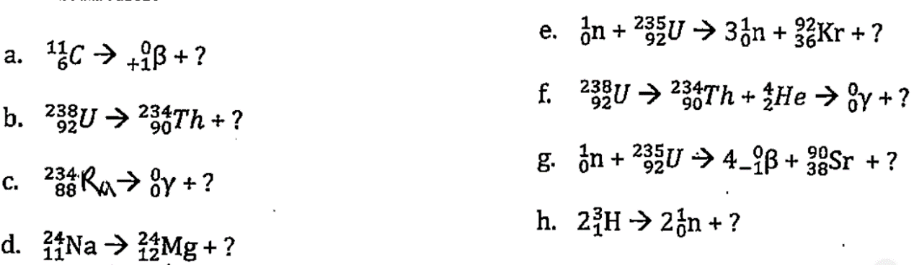

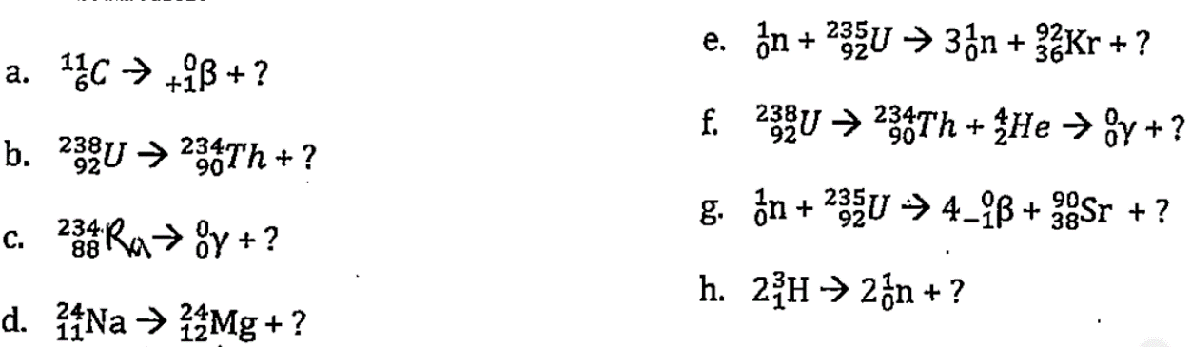

**Write the balanced equations for:**

1. Positron emission from Sulfur-31 (emission means it releases/produces that particle)
2. Krypton-76 undergoes electron capture (means that it absorbs a beta particle)
3. Neutron initiated fission of U-235 results in the release of 2 neutrons, the formation of Cs-144 and another atom (means the uranium is being hit with the neutron to make all those particles mentioned).
4. Bombardment of Cl-35 with a neutron produces a sulfer-34 nucleus and another particle (means you are hitting the Cl-35 with the neutron)
5. Bismuth-214 can take two paths using Alpha and Beta decay to produce a new nucleus. Write out the equation for the two paths. (Means that this is a decay series – do an alpha reaction first, then that daughter product undergoes a beta reaction)
6. Which particles make up the nucleus?
7. Why do we say that the mass of an atom is in the nucleus?
8. Copy the chart Mrs. Farmer projects on the board - fill in the info that is missing:
9. Complete the nuclear rxns below. Question Marks are unknown elements

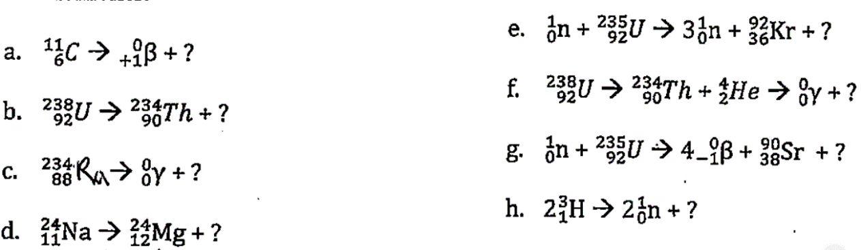



**Write the balanced equations for:**

1. Positron emission from Sulfur-31 (emission means it releases/produces that particle)
2. Krypton-76 undergoes electron capture (means that it absorbs a beta particle)
3. Neutron initiated fission of U-235 results in the release of 2 neutrons, the formation of Cs-144 and another atom (means the uranium is being hit with the neutron to make all those particles mentioned).
4. Bombardment of Cl-35 with a neutron produces a sulfer-34 nucleus and another particle (means you are hitting the Cl-35 with the neutron)
5. Bismuth-214 can take two paths using Alpha and Beta decay to produce a new nucleus. Write out the equation for the two paths. (Means that this is a decay series – do an alpha reaction first, then that daughter product undergoes a beta reaction)
6. Which particles make up the nucleus?
7. Why do we say that the mass of an atom is in the nucleus?
8. Copy the chart Mrs. Farmer projects on the board - fill in the info that is missing:
9. Complete the nuclear rxns below. Question Marks are unknown elements





**Write the balanced equations for:**

1. Positron emission from Sulfur-31 (emission means it releases/produces that particle)
2. Krypton-76 undergoes electron capture (means that it absorbs a beta particle)
3. Neutron initiated fission of U-235 results in the release of 2 neutrons, the formation of Cs-144 and another atom (means the uranium is being hit with the neutron to make all those particles mentioned).
4. Bombardment of Cl-35 with a neutron produces a sulfer-34 nucleus and another particle (means you are hitting the Cl-35 with the neutron)
5. Bismuth-214 can take two paths using Alpha and Beta decay to produce a new nucleus. Write out the equation for the two paths. (Means that this is a decay series – do an alpha reaction first, then that daughter product undergoes a beta reaction)