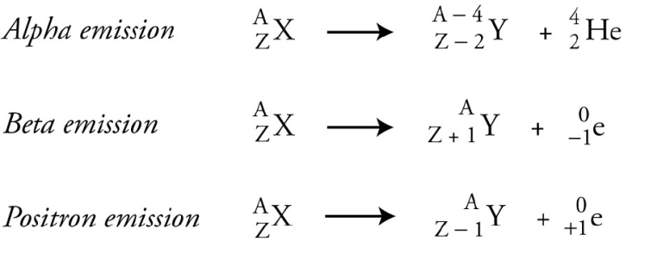

*Gamma emission*



*Gamma emission*



*Gamma emission*



*Gamma emission*



*Gamma emission*



*Gamma emission*



*Gamma emission*



*Gamma emission*