|  |  |  |  |  |
| --- | --- | --- | --- | --- |
| **Writing Nuclear Equations** | | | | |
| **#** | **Q** | | | |
| 1 | Describe what happens to a nucleus during radioactive decay | |  | |
| 2 | Fill in the following for the three types of decay | | | |
| Property | Alpha | Beta | Gamma |
| What is it? |  |  |  |
| Symbol |  |  |  |
| Charge |  |  |  |
| What stops it? |  |  |  |
| 3 | Which type of radiation is a packet of energy (photon) or a wave? | | |  |
| 4 | What type of radiation is a  helium nucleus? | | |  |
| 5 | Which type of radiation is a super fast moving electron? | | |  |
| 6 | What type of decay results in an increase in the atomic number for the decay product | | |  |
| 7 | Which type of decay results in no change in atomic number for the decay product | | |  |



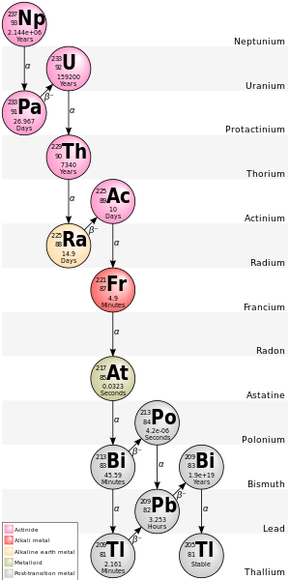

Describe what you see happening in this image. Include specifics as “evidence” to back up what you are seeing. Use full sentences.

GLUE THIS PART DOWN

*Nuclear Particles and Equations “Free Choice” – see p. 7 for ideas*