Alien Periodic Table

Introduction
- Your task is to arrange the Aliens in some logical pattern so that they form an organized rectangular block.
- Within each group, all the Aliens in that group must be exactly the same in some way (the Key Similarity), AND must also share a feature that changes regularly as you move down the group (the Varying Trait).
- Within each period, all the Aliens in the period must be exactly the same in some way (the Key Similarity), AND must also share a feature that changes regularly as you move across the period (the Varying Trait).
- Two Aliens are missing from your set; simply leave empty spaces in your rectangular block for these Aliens.
- Once you have finished arranging your Aliens, have your teacher check it and to sign your paper.
- Be prepared to answer any questions the teacher may have about how you arranged the Aliens.
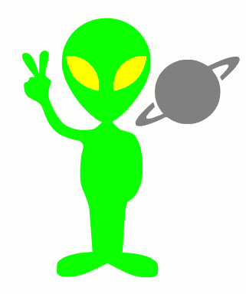
- Good luck!

DECK LETTER: TEACHER STAMP:

1) How many groups of Aliens do you have? ________ How many periods of Aliens do you have? ________

2) ALL ABOUT THE MISSING ALIENS
For each Alien that is missing…list five statements describing what it looks like, and draw it neatly.

DESCRIPTION OF MISSING ALIEN #1 DRAWING OF MISSING ALIEN #1

I.

II.

III.

IV.

V.

DESCRIPTION OF MISSING ALIEN #2 DRAWING OF MISSING ALIEN #2

I.

II.

III.

IV.

V.

3) GIVE DETAILED INFORMATION ABOUT YOUR TABLE OF ALIENS.
- List if you are describing a GROUP or a PERIOD
- List the group or period NUMBER.
- List the Key Similarity for the Aliens in that group or period -
(what does everything in that group or period have in common)
- List the Varying Trait for the Aliens in that group or period. Be specific, yet concise. -
(what is the characteristic in that group or period that changes in a PREDICTIBLE and PATTERNED
way…not everything that is different! )

Group or Period | Number | Key Similarity | Varying Trait

4) THE ‘NEXT’ ALIEN? Pick a NEW group and period that is not already part of your alien table.
Describe what the ‘Next’ Alien might look like, and neatly draw what it might look like.

GROUP NUMBER = __________ PERIOD NUMBER = __________

DESCRIPTION OF THE ‘NEXT’ ALIEN DRAWING OF THE ‘NEXT’ ALIEN

“The ‘Next’ Alien almost certainly has…”

“Things about the ‘Next’ Alien we really don’t know…”

- What similarities and differences does this table have to Earth’s periodic table?

