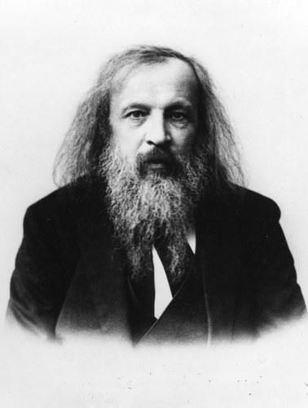 [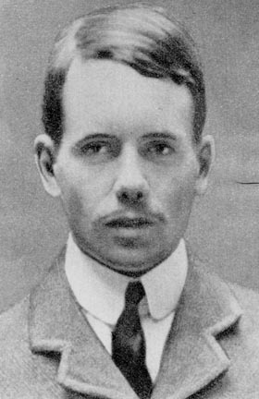](http://www.library.upenn.edu/etext/smith/m/moseley.jpg)  [](http://www.library.upenn.edu/etext/smith/m/moseley.jpg)

 [](http://www.library.upenn.edu/etext/smith/m/moseley.jpg)  [](http://www.library.upenn.edu/etext/smith/m/moseley.jpg)

 [](http://www.library.upenn.edu/etext/smith/m/moseley.jpg)  [](http://www.library.upenn.edu/etext/smith/m/moseley.jpg)