Periodic Table Vocabulary

Vocabulary Assignment:

Match up the boxes so that each side matches with the correct term/definition/description (including the outside edges and opposite ends). When you are done, you should have 18 vocabulary terms/concepts to remember. Write them down here.

Here’s a hint: when laid out correctly, the answer to this riddle will appear in the boxes.

What kind of bear has no teeth?

Answer:__________________________

Definitions/concepts:

1. _____________________________________________________________________________________­_  
     
   ______________________________________________________________________________________
2. _____________________________________________________________________________________­_  
     
   ______________________________________________________________________________________
3. _____________________________________________________________________________________­_  
     
   ______________________________________________________________________________________
4. _____________________________________________________________________________________­_  
     
   ______________________________________________________________________________________
5. _____________________________________________________________________________________­_  
     
   ______________________________________________________________________________________
6. _____________________________________________________________________________________­_  
     
   ______________________________________________________________________________________
7. _____________________________________________________________________________________­_  
     
   ______________________________________________________________________________________
8. _____________________________________________________________________________________­_  
     
   ______________________________________________________________________________________
9. _____________________________________________________________________________________­_  
     
   ______________________________________________________________________________________
10. _____________________________________________________________________________________­_  
      
    ______________________________________________________________________________________
11. _____________________________________________________________________________________­_  
      
    ______________________________________________________________________________________
12. _____________________________________________________________________________________­_  
      
    ______________________________________________________________________________________
13. _____________________________________________________________________________________­_  
      
    ______________________________________________________________________________________
14. _____________________________________________________________________________________­_  
      
    ______________________________________________________________________________________
15. _____________________________________________________________________________________­_  
      
    ______________________________________________________________________________________
16. _____________________________________________________________________________________­_  
      
    ______________________________________________________________________________________
17. _____________________________________________________________________________________­_  
      
    ______________________________________________________________________________________
18. _____________________________________________________________________________________­_  
      
    ______________________________________________________________________________________

Teacher instructions:

* Print a copy of the 3x3 grid.
* Write your 9 character message in the squares, left to right, top to bottom like in the picture:

(I usually use a marker to write the letters before photocopying.)

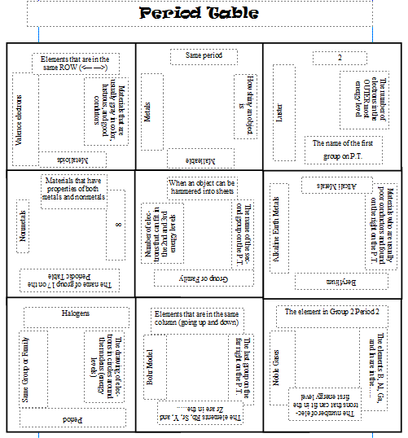

**M**

**B**

**M**

**U**

**I**

**G**

**A**

**E**

**R**

**The definitions/concepts and vocabulary words wrap L-R and Top/bottom**

* Give the students the Center Letter (I in this case. I always have that one straight up)
* Definitions and vocab words are on touching sides within the grid. (12 answers)
* Definitions wrap around top bottom and left-right. (6 answers) If you don’t give central letter, other solutions are possible!
* Cut along the solid lines, put the pieces into baggies or paper clips and distribute to students. When they are done, compare their answers with an uncut puzzle – the letters form an easy visual key for you as you check answers.
* The order of answers on the answer sheet is not important as long as they have 18
* I usually have some uncut puzzles for students who need more time (so I can collect the cut puzzles).
* I let students use the answers on future assignments. I give them the below key if absent on puzzle day.

Periodic Table Vocab review

Vocabulary Assignment:

Match up the boxes so that each side matches with the correct term/definition/description (including the outside edges and opposite ends). When you are done, you should have 18 vocabulary terms/concepts to remember. Write them down here.

When completed you will have the answer to this question:

Q - What kind of bear has no teeth?

Answer:____**Gummi bear**_______

Definitions/concepts:

1. The drawing of electrons in circles around the nucleus (energy levels) is **the Bohr Model.**
2. Elements that are usually poor conductors and found on the right on the P.T. are **non-metals**.
3. The name of Group 1 on the Periodic Table is the **Alkali Metals.**
4. **Luster** is how shiny an object is.
5. A **period** is elements that are all in the same row.
6. **Valence electrons** are electrons in the outermost shell.
7. The number of electrons that can fit in the 1st energy level is **2.**
8. **Metals** are elements that are usually gray in color, lustrous, and good conductors of heat, electricity.
9. The name of Group 2 on the Periodic Table is the **Alkaline Earth Metals.**
10. **Malleable** is when an substance can be hammered into sheets.
11. Elements that are in the same column (going up and down) are a **group or family.**
12. **Metalloids** are elements that have properties of both metals and nonmetals
13. The number of electrons that can fit in the 2nd and 3rd energy levels is **8.**
14. Group 18 on the far right on the P.T. are the **Noble gases.**
15. The elements B, Al, Ga, and In are in the **same group.**
16. **Beryllium** is the element in group 2, period 2.
17. The elements Rb, Sr, Y, and Zr are in the **same period.**
18. **Halogens** is the name of group 17 on the Periodic Table.