**CLASS COPY! DO NOT TAKE OR WRITE ON!**

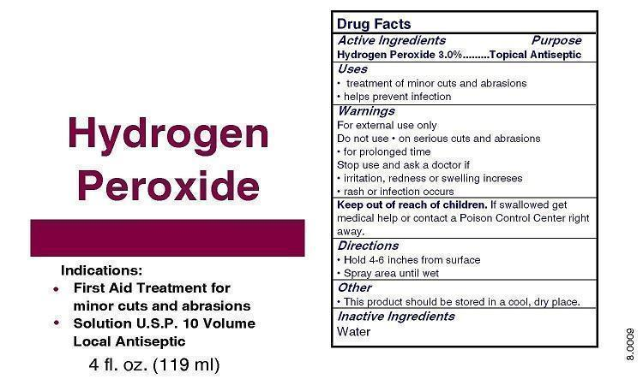

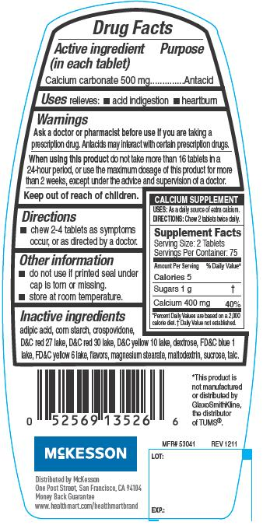

Titanium (i

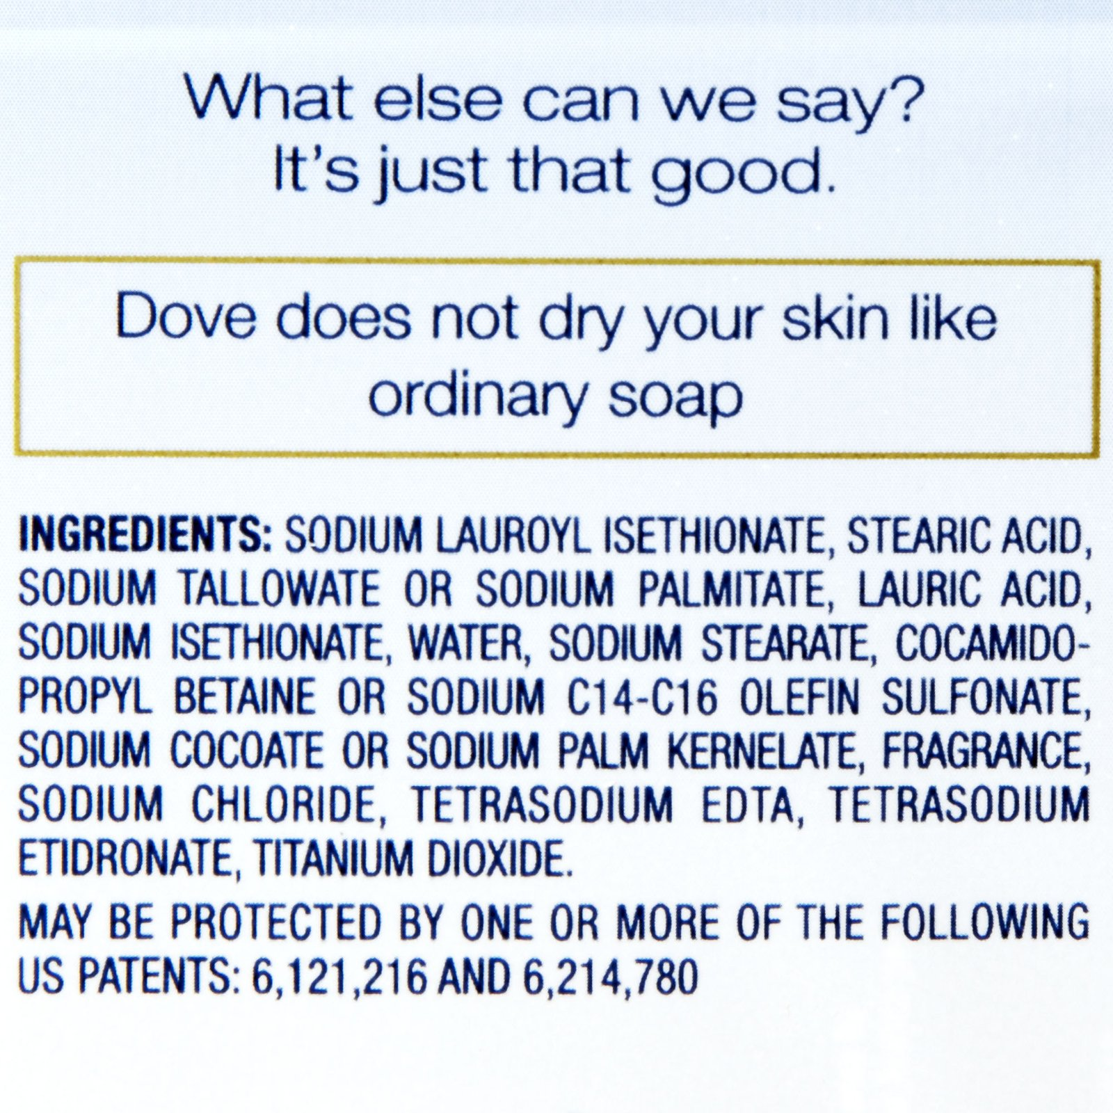**Q:** What is wrong with this name?! What should the name be?

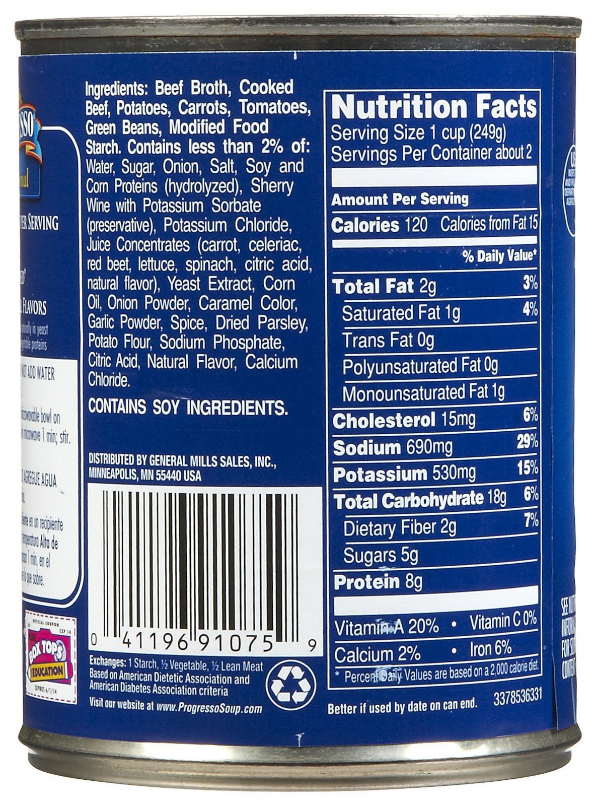

**Salami ingredients:** Pork, Salt, Sugar, Wine, Spices, Dextrose, Garlic, Ascorbic Acid, Lactic Acid, Sodium Nitrite, Sodium Nitrate.

**CLASS COPY! DO NOT TAKE OR WRITE ON!**





Titanium (i

**Q:** What is wrong with this name?! What should the name be?



**Salami ingredients:** Pork, Salt, Sugar, Wine, Spices, Dextrose, Garlic, Ascorbic Acid, Lactic Acid, Sodium Nitrite, Sodium Nitrate.