Naming Pyramid

|  |  |
| --- | --- |
| **Name** | **Formula** |
|  |  |
|  |  |
|  |  |
|  |  |
|  |  |
|  |  |
|  |  |
|  |  |
|  |  |
|  |  |
|  |  |
|  |  |
|  |  |
|  |  |
|  |  |
|  |  |
|  |  |
|  |  |
| Were these Ionic Compounds or Covalent Molecules? |  |
| Why do some use roman numerals? |  |
| Why do you have to “cross over” when writing compounds? |  |

*Glue this part down to your notebook page*

Covalent Cups

Take one slip of paper from each cup and write the name and formula for the molecule it creates.

|  |  |
| --- | --- |
| **Name** | **Formula** |
|  |  |
|  |  |
|  |  |
|  |  |
|  |  |
|  |  |
|  |  |
|  |  |
|  |  |
|  |  |
|  |  |
|  |  |
|  |  |
|  |  |
|  |  |

1. What class of elements bond together to make a molecule?
2. What do the electrons do in a covalent molecule that is different than what they do in an ionic compound?
3. What are the properties of ionic compounds vs covalent molecules?   
    Ionic Covalent

Covalent Molecule Prefix Mnemonic

Develop a mnemonic that helps you remember the first ten prefixes for use in naming covalent molecules.

|  |
| --- |
|  |

Naming Flow Chart

Create a flow chart that walks someone through how to name a chemical. *Hint -* they need to start by deciding if it is ionic or covalent!

|  |
| --- |
|  |

Ion Soup  
A soup of ions needs to be grouped into neutral ionic compounds. Unfortunately, the charges on the ions got lost when the soup was spilled. You’ll have to work out the charges yourself so that you can put the compounds together. Also, you should have **no uncircled ions** when you’re done. The first compound has been completed to start you off. Good luck!

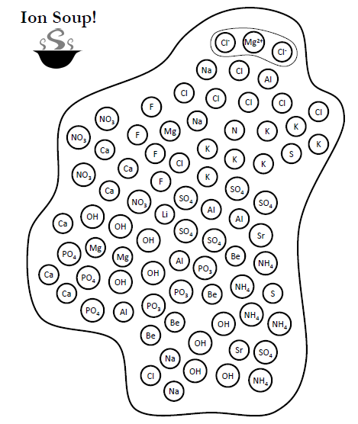

List the formulas and names of all the compounds you circled in the ion soup. You do not need to list the same formula more than once.

|  |  |
| --- | --- |
| **Name** | **Formula** |
|  |  |
|  |  |
|  |  |
|  |  |
|  |  |
|  |  |
|  |  |
|  |  |
|  |  |
|  |  |
|  |  |
|  |  |
|  |  |
|  |  |
|  |  |
|  |  |
|  |  |
|  |  |
|  |  |
|  |  |
|  |  |
|  |  |