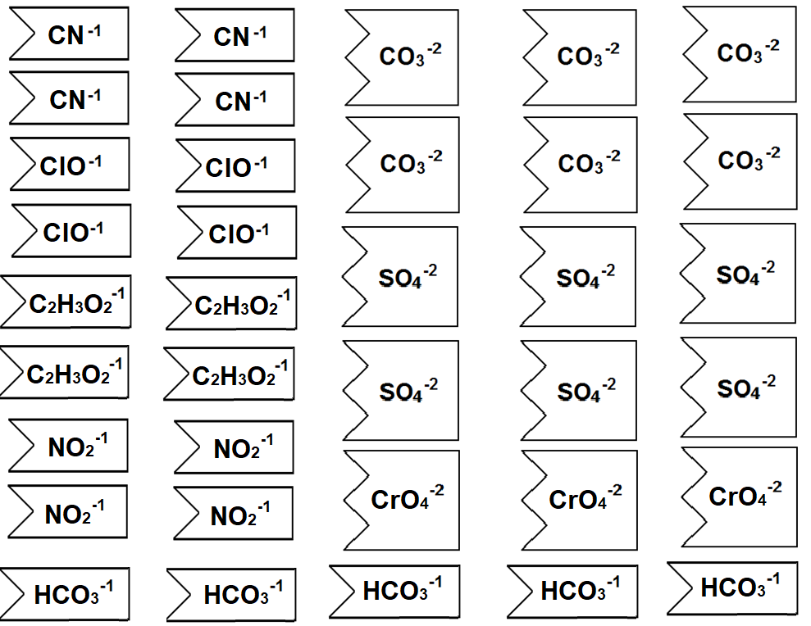

**🡨 Color Everything GREY 🡪**