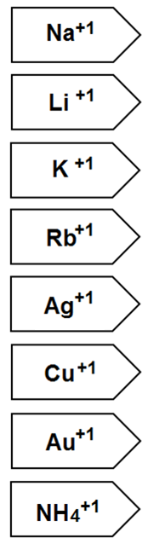    

🡨 GREY🡪

🡨 YELLOW 🡪

🡨 Color these RED 🡪

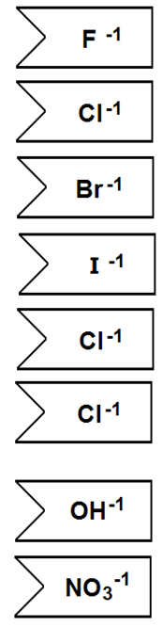    

🡨 GREY 🡪

🡨 Color these PURPLE 🡪