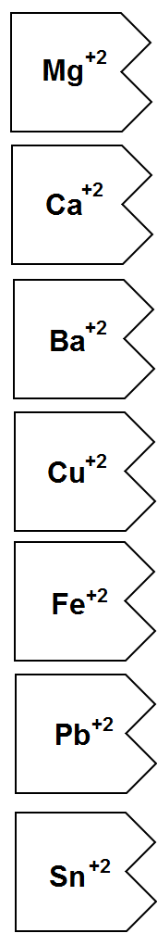 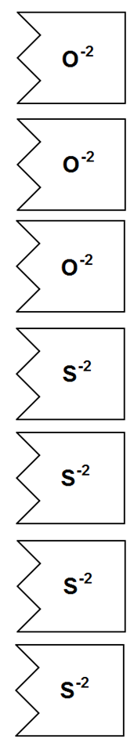

**🡨 Color these LIGHT BLUE Color these LIGHT BLUE Color these LIGHT BLUE 🡪**

**🡨 Color these YELLOW 🡪**

🡨 Color these ORANGE 🡪