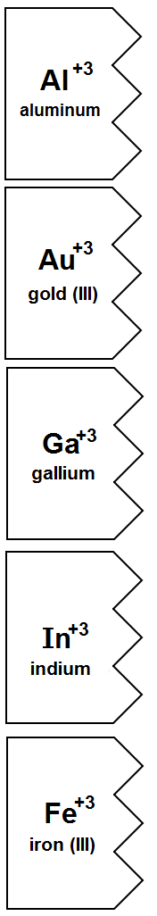 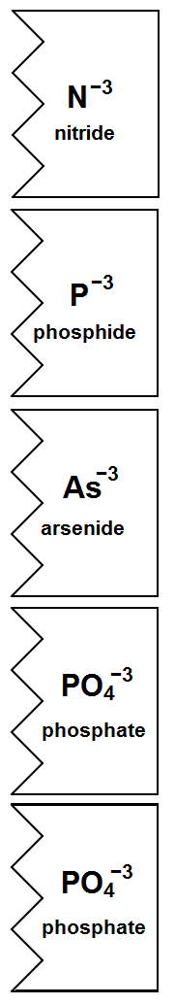

**🡨 Color these BROWN 🡪**

**🡨 Color these GREY 🡪**

**🡨 Color these YELLOW 🡪**

**🡨 Color these GREEN 🡪**