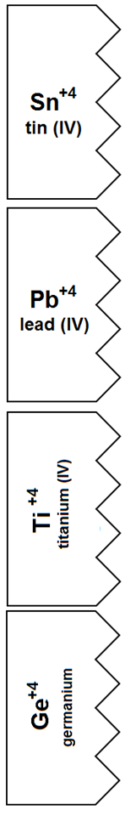   

**🡨 Color this one DARK BLUE 🡪**

**🡨 Color these YELLOW 🡪**