**UNIT 5 IONIC BONDING PROJECT**

**COLOR CODING CHART**

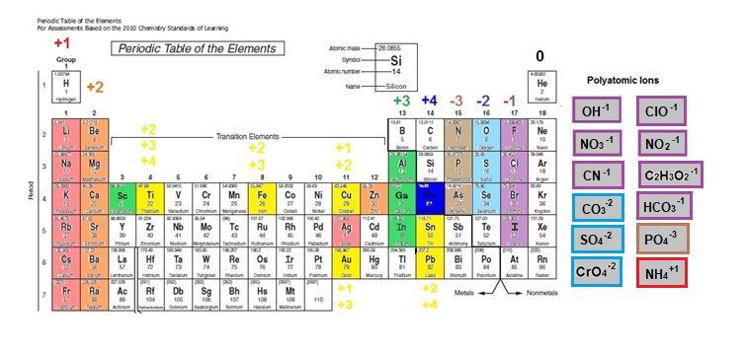

**Color Coding Instructions:**

* **+1 ions – red**
* **+2 ions – orange**
* **Transition Metals – yellow**
* **+3 ions - green**
* **+4 ion – dark blue**
* **-3 ions – brown**
* **-2 ions – light blue**
* **-1 ions – purple**
* **Polyatomic ions – grey**

**NOTE: The border of the polyatomic ions should match the color of the ion’s charge.**