**Unit 5 – Ionic Bonding Test Project**

Use the color code diagram below to color each ion. Then cut out the ion shapes and combine the positive cations with the negative anions to create a balanced ionic bond. Glue each cation and anion combination onto the construction paper provided by your teacher. Write the formula and name under each compound.

**Criteria for Test Grade:**

* You must create at least **20 different ionic compounds**.
  + Combine the cations and anions so that the **net charge is zero**
  + write the **chemical formula** for every ionic bond created
  + write the **chemical name** for every ionic bond created
* You may create as many of each type as you like, as long as you:
  + include all oxidation numbers: **+1, -1, +2, -2, +3, -3,** and **+4**
  + include at least **6 different polyatomic ions** in your project
  + include at least **3 different transition metals** in your project

***This project is due on ______________________ at the end of class.***

***Students will lose 10 points for each day it is late.***

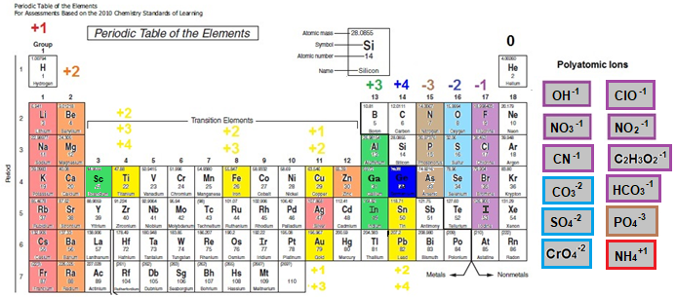

**Unit 5 – Ionic Bonding Test Project Rubric**

| **Criteria** | **Grading Scale** |
| --- | --- |
| **Appropriate Use of Time**  ***Playing on cell phones, talking without working on project, or gaming on computers will result in a score of 0 for this section. Parents will be notified immediately.*** | |  |  |  |  | | --- | --- | --- | --- | | **10**  **Excellent** –  Focused on getting the project done. Always on task. Helped clean up. | **7.5**  **Good** -  Focused on getting the project done. Mostly on task. Helped clean up. | **5**  **Satisfactory** -  Got the project done  but was off task at times. Did not help clean up. | **0 - 2.5**  **Needs Improvement** Did not use class time appropriately. Did not did not help clean up. | |
| **Color Code**  Ions were colored in based on color coding chart provided in the project criteria. | |  |  |  |  | | --- | --- | --- | --- | | **15**  **Excellent** –  All ions were colored according to the chart given in the instructions. | **10**  **Good** –  Most ions were colored according to the chart given in the instructions. Only 1-2 errors were found. | **5**  **Satisfactory** –  Some ions were colored according to the chart given in the instructions. Only 2-3 errors were found. | **0 - 2.5**  **Needs Improvement** - Needs Improvement -Ions were not colored according to the instructions. Contained 4 or more errors. | |
| **Ionic Bonding**  Project included 20 different ionic bonds, including 6 with polyatomic ions and 3 with transition metals.  **SCI.9-12.CH.3.d**  bonding types; | |  |  |  |  | | --- | --- | --- | --- | | **25**  **Excellent** –  All ionic bonds were balanced and all ion combinations were included in the project. | **20**  **Good** –  All ionic bonds were balanced but 1 ion combination was missing from the project. | **15**  **Satisfactory** –  All ionic bonds were balanced but 2 ion combinations were missing from the project. | **0 - 10**  **Needs Improvement** - Some ionic bonds were not balanced and/or 3 or more ion combination were missing from the project. | |
| **Chemical Formula**  Ionic formulas were written using IUPAC rules.  **SCI.9-12.CH.3.c**  writing chemical formulas; | |  |  |  |  | | --- | --- | --- | --- | | **25**  **Excellent** –  All ionic formulas were written according to the IUPAC rules. | **20**  **Good** –  Most ionic formulas were written according to the IUPAC rules. Only 1 error was found. | **15**  **Satisfactory** –  Some ionic formulas were written according to the IUPAC rules. Only 2 errors were found. | **0 - 10**  **Needs Improvement -** Ionic formulas were not written according to the IUPAC rules. Three or more errors were found. | |
| **Chemical Name**  Ionic names were written based on IUPAC rules.  **SCI.9-12.CH.3.a**  nomenclature; | |  |  |  |  | | --- | --- | --- | --- | | **25**  **Excellent** –  All ionic names were written according to the IUPAC rules. | **20**  **Good** –  Most ionic names were written according to the IUPAC rules. Only 1 error was found. | **15**  **Satisfactory** –  Some ionic names were written according to the IUPAC rules. Only 2 errors were found. | **0 - 10**  **Needs Improvement -** Ionic names were not written according to the IUPAC rules. Three or more errors were found. | |

**Total Score: ________ / 100**

**Comments: _____________________________________________________________________________________________________________________________________________________________________________________________________________________**