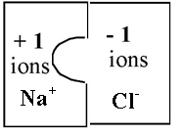
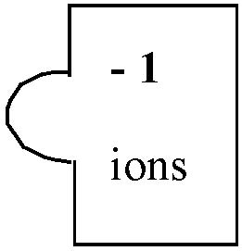
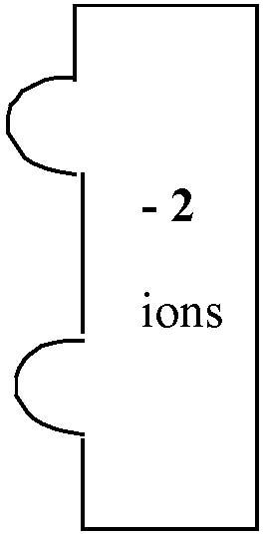
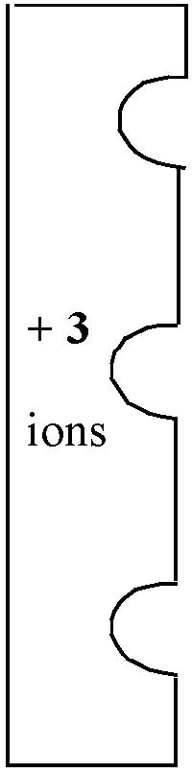
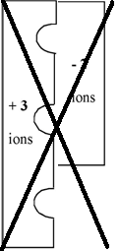

Ionic Compound Puzzle Pieces

You have had a couple of days experience balancing ionic-compound formulas, getting the cations and ions properly balanced. To get a visual feel for how to combine ions, let's use ion puzzle pieces to make ionic compounds. One has to cut them out and glue them together. For example, Sodium Chloride when completed and labeled will look like this:

Label each Write the formula
ion piece below the puzzle pieces
Remember to use subscripts!
NaCl

Compound | Cation  Do before | Anion  Do before | Formula  Do after
Lead (II) Hydroxide | Pb²⁺ | OH⁻ | Pb(OH)₂
Copper (I) chloride
Copper (II) iodide
Magnesium oxide
Aluminum Carbonate
Ammonium Dichromate
You have to make a neutral You can only use one type
compound! No left over “tabs” Of anion and one type of
or “cut-outs.” cation per compound.

- Label all ion puzzle pieces. See above.
- Add up ions to get formulas.
- The number of atoms or polyatomic ions must be subscripted: Ag₂CO₃
- If element symbol has two letters, second must be lowercase.
- Don't forget to put polyatomic ions in parentheses if more than one and subscript the number: Al(OH)₃

Ionic Compound Puzzle Pieces

You have had a couple of days experience balancing ionic-compound formulas, getting the cations and ions properly balanced. To get a visual feel for how to combine ions, let's use ion puzzle pieces to make ionic compounds. One has to cut them out and glue them together. For example, Sodium Chloride when completed and labeled will look like this:

Label each Write the formula
ion piece below the puzzle pieces
Remember to use subscripts!
NaCl

Compound | Cation  Do before | Anion  Do before | Formula  Do after
Lead (II) Hydroxide | Pb²⁺ | OH⁻ | Pb(OH)₂
Copper (I) chloride
Copper (II) iodide
Magnesium oxide
Aluminum Carbonate
Ammonium Dichromate
You have to make a neutral You can only use one type
compound! No left over “tabs” Of anion and one type of
or “cut-outs.” cation per compound.

- Label all ion puzzle pieces. See above.
- Add up ions to get formulas.
- The number of atoms or polyatomic ions must be subscripted: Ag₂CO₃
- If element symbol has two letters, second must be lowercase.
- Don't forget to put polyatomic ions in parentheses if more than one and subscript the number: Al(OH)₃

