|  |  |  |  |
| --- | --- | --- | --- |
| Real Life Examples of Intermolecular Forces | |  |  | | --- | --- | |  |  | |

**Plants**

Water is transported throughout the structure of a plant by the intermolecular forces of adhesion and cohesion. Water moves through a xylem tube which is an incredibly small space for substances to pass through. However, through capillary action water can move simply by the ability for the water to cling to the plant surface walls. As a result all the plants you see and eat use intermolecular forces.

**Soaps and Detergents**

Molecules liquid state experience strong intermolecular attractive forces. When those forces are between like molecules, they are referred to as cohesive forces. the molecules of a water droplet are held together by cohesive forces, and the especially strong cohesive forces at the surface to form surface tension. Soap and detergents help the cleaning of clothes by lowering the surface tension of the water so that it more readily soaks into pores and soiled areas.   
**Adhesives (between different molecules)**

|  |  |  |  |
| --- | --- | --- | --- |
| **FOOD INDUSTRY**  The modern way of food retailing and self-service with its ready-to-eat meals, frozen products and instant foods would be unimaginable without adhesives for manufacturingimpermeable packaging materials, such as laminated films, or for hermetically sealing packaging. | **MEDICAL INDUSTRY**  Adhesives are used extensively in the medical world, from simple plasters to advanced medical applications. Adhesives are integral to the production of paper tissues and nappies, allow tablets to be protected from the effects of moisture and allow wounds to be dressed.Trans dermal patches, such as the nicotine patch, permit a controlled delivery of nicotine into the bloodstream to help smokers quit. | **TECHNOLOGY**  In the area of electronics, the classic joining technique of soldering is being increasingly replaced bybonding, in order for example to connect highly integrated components with each other in a stress-free way and without the need to use excessive heat. | **ENGINEERING**  The aircraft manufacturing industry provided the key technology impulse for modern bonding technology. The basic need for weight saving was the driving force for new design and construction methods. In modern Airbus aircraft, for example, about 30% of allcomponents are joined using bonding technology. |

**Proteins**

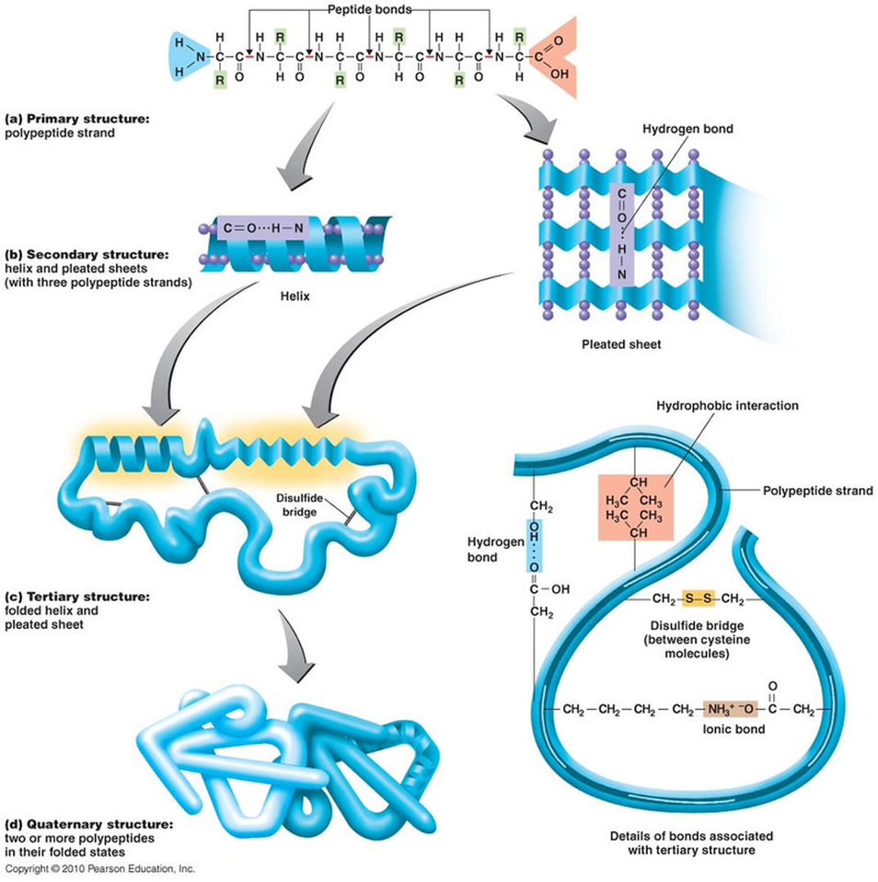The primary structure of a protein is a polypeptide which is a polymer of amino acids .Polypeptide chains form a helical structure owing to the hydrogen bonds formed between the N-H and C=O groups. This creates the secondary structure of proteins . In many proteins, including those in hair, wool and nails. Hydrogen bonding causes the polypeptide chains to become twisted into tightly coiled helices.

**CREATE A FREE WEBSITE**

**How Gecko’s Stick**

Van der Waals forces, named after a Dutch physicist of the late 1800s, are weak electrodynamic forces that operate over very small distances but bond to nearly any material.

Geckos have millions of setae—microscopic hairs on the bottom of their feet. These tiny setae are only as long as two diameters of a human hair. That's 100 millionth of a meter long. Each seta ends with 1,000 even tinier pads at the tip. These tips, called spatulae, are only 200 billionths of a meter wide—below the wavelength of visible light.

"Intermolecular forces come into play because the gecko foot hairs split and allow a billion spatulae to increase surface density and come into close contact with the surface. This creates a strong adhesive force," said Autumn.

A single seta can lift the weight of an ant. A million setae, which could easily fit onto the area of a dime, could lift a 45-pound child. If a gecko used all of its setae at the same time, it could support 280 pounds.

**More about Gecko Feet**

The unique ability of geckos to scale walls and suspend from ceilings has attracted the interest of naturalists for ages, dating back to Aristotle’s observations in his *History of Animals* of the creature’s ability to “run up and down a tree in any way.”[[1]](http://web.stanford.edu/group/mota/education/Physics%2087N%20Final%20Projects/Group%20Gamma/gecko.htm" \l "_edn1" \o ")  It is only recently that scientists have unlocked the secret behind the lizards’ perplexing mobility and begun engineering synthetic materials mimicking their abilities.

**Gecko Feet Structure and Intermolecular Forces**

A gecko’s foot has toepads consisting of about half a million setae made of keratin.  Each of these fine hairs has hundreds of even smaller projections of nanoscale diameters called spatulae protruding from their ends.[[2]](http://web.stanford.edu/group/mota/education/Physics%2087N%20Final%20Projects/Group%20Gamma/gecko.htm" \l "_edn2" \o ")  While many interactions had been hypothesized as the origin of the adhesion, such as suction, friction, and electrostatic forces, it was not until 2000 that Robert Full of the University of California, Berkeley, discovered that the adhesion was due to van der Waals forces created between the spatulae and the surface.[[2]](http://web.stanford.edu/group/mota/education/Physics%2087N%20Final%20Projects/Group%20Gamma/gecko.htm" \l "_edn2" \o ")  Van der Waals forces are intermolecular forces created by induced polarizations of molecules.  Though weak and negligible in most considerations, van der Waals forces become significant on the micro and nanoscale.  In the case of gecko feet, the spatulae are so small and get so close to the surface that an attractive van der Waals force of around 0.4 µN develops between a single spatula and a surface.[[2]](http://web.stanford.edu/group/mota/education/Physics%2087N%20Final%20Projects/Group%20Gamma/gecko.htm" \l "_edn2" \o ")  While a seemingly insignificant number, the combined force of the millions of spatulae on a single gecko foot produce an adhesion force of around 10 N, or around 2.25 lbs.[[2]](http://web.stanford.edu/group/mota/education/Physics%2087N%20Final%20Projects/Group%20Gamma/gecko.htm" \l "_edn2" \o ")  Considering a gecko foot has an area around only 100 mm2, it was inevitable that scientists would attempt to mimic the power and efficiency of such a material.

**Fabricating Nature**

In 2003, Andre Geim and fellow researchers at the University of Manchester succeeded in creating a synthetic material that mimics gecko feet called gecko tape.  While composed of a different material, gecko tape has a similar structure to the toepads of the lizards.  The fabrication process of the tape involves many cutting edge nanotechnology methods.  First, a polyimide film substrate is prepared on a silicon wafer.  Then an aluminum mask is created through electron beam lithography, a process where a beam of electrons is used to create nanoscale patterns on a surface.[[3]](http://web.stanford.edu/group/mota/education/Physics%2087N%20Final%20Projects/Group%20Gamma/gecko.htm" \l "_edn3" \o ")  This mask is then transferred to the polyimide film through dry etching, a procedure where ions are bombarded against the metal to remove the mask, leaving only the substrate and the projecting polyimide hairs.  The material is then removed from the silicon wafer and attached to a flexible base, which allows the material to adhere better to surface, which is usually not flat due to microscopic imperfections.[[3]](http://web.stanford.edu/group/mota/education/Physics%2087N%20Final%20Projects/Group%20Gamma/gecko.htm" \l "_edn3" \o ")  In order to test the adhesive force of the resulting array of polyimide hairs, Geim used an atomic force microscope (AFM) with a cantilever tip and measured the deflection of the tip.  As hypothesized, each hair had around the same adhesive force as a single gecko seta.[[3]](http://web.stanford.edu/group/mota/education/Physics%2087N%20Final%20Projects/Group%20Gamma/gecko.htm" \l "_edn3" \o ")

**The Future of Biomimetic Adhesives**

While many problems still obstruct immediate commercial applications of gecko tape, such as poor durability and high fabrication costs, the prospects of the technology are still generating excitement in a variety of fields.  An adhesive material that exploits intermolecular forces could be crucial in certain environments where conventional adhesion tools such as suctions and glues cannot function; for instance, a descendent of gecko tape might enable astronauts to perform spacewalks with the tape affixing the astronaut’s boots to the spacecraft, eliminating the need for complex harnesses.  In more typical circumstances, the incredible strength of gecko tape could be used in a myriad of applications, such as increased mobility for humans in construction, inspection, and military situations.  The fact remains that as we progress in our understanding and utilization of the most fundamental forces of nature, we will be able to approach problems once though unsolved from a new direction, specifically, from the bottom-up.