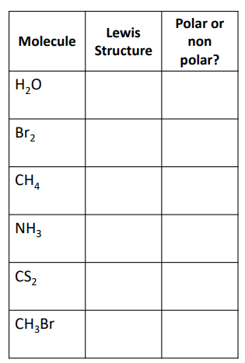Dear Regular Chemistry Students (Periods 1, 2, 3)

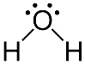**Complete the following while I am gone. You can use  
the boxes to check things off as you go since there are a lot  
of little things to get done today. Thank you!**

POLAR

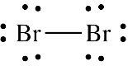

NON-POLAR

1. 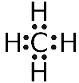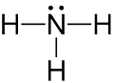Use the answer key to the right to correct your   
   homework p.144. If you were absent or didn’t do your   
   homework, please don’t just copy it! Please do the   
   work first, then check your answers.

POLAR

NON-POLAR

1. Get a copy of the “Polar Bear Polarity Comic”   
   from the substitute.
   1. It is a class copy, please do not take!

NON-POLAR

* 1. Take notes on the back of this paper.
  2. 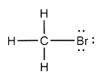Have the sub stamp your notes when done
  3. This paper will get folded in half and put in the  
     pocket on p.143. I will check and grade it later.

POLAR

1. Give the copy of the comic back to the substitute.
2. Get a copy of the “Properties due to Intermolecular Forces” packet.
   1. This is a print out of the PowerPoint notes on this topic.
   2. It is a class copy, please do not take! If you need a copy of the notes, you can find them on the class website like normal.
   3. Set up KCQ Boxes on p.147
   4. Write the following target at the top of p.147:
      1. Target: *I can describe how Intermolecular Forces affect properties*
   5. Read the PowerPoint and take notes on p.147
      1. Make sure you watch the videos also – they are important parts of the notes. If you do not have a phone and headphones to watch the videos in class, then make sure to watch them at home and add notes about them to p.147 tonight.
3. Give the “Properties due to Intermolecular Forces” packet back to the substitute.
4. If you finished #1-5, you may do one of the following. Whatever you do not finish turns into homework, so please use all your class time effectively so you don’t have a lot of homework!

**HOMEWORK:**

* + 1. Add color annotations to p.147 to pull out key information
       - Due Friday, January 10
    2. Fill out your KCQ boxes on p.147
       - Due Friday, January 10
    3. Finish your “plus, minus, delta” chart on p.140  
       Remember – you need to submit a legible photograph of this page to Google Classroom so I can read it and grade it.
       - Due Monday, January 13
    4. Finish the “8 most missed questions from the fall final” on p.141
       - Due Monday, January 13

Name: ___________________________ Period: _____ Seat #: _____

Polar Bear Polarity Notes

* **Take notes on the “Polar Bear Polarity” comic.**
* **You can do bullet points, sketch parts of the comic, write sentences summarizing it, etc.**
* **When you are done taking the notes, draw a line all the way across the page where your notes end.**
* **The substitute will stamp your notes directly under the line you drew. This way I know what notes you took in class, and that you didn’t go home and add to them.**
* **You will keep this paper in the pocket on p. 143. I will check it and grade it later.**