Types of IMFs QR Code Sheet
Free App: Quick Scan – QR Code Reader Website: www.webqr.com
#1  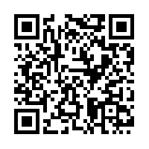  http://tinyurl.com/ChemWikiIMFs | #4 – Menu choices on the left  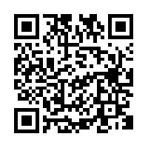 http://tinyurl.com/PurdueIMFs
#2 – Focus on the animations    http://tinyurl.com/WiscIMFs | #5   http://tinyurl.com/RosengartenIMFs
#3  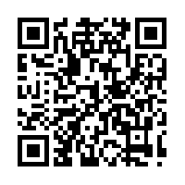 http://tinyurl.com/CrashCourseIMFs | #6  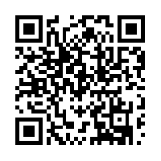 http://tinyurl.com/ElmhurstIMFs

