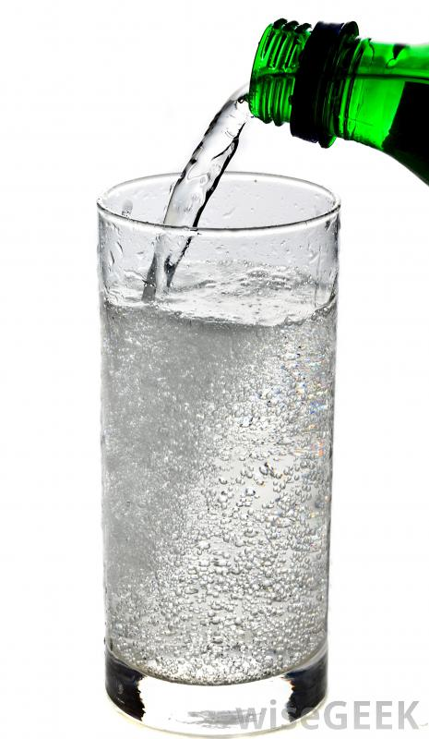Decomposition of Acids

Certain acids decompose into nonmetal oxides and water. Carbonic acid is unstable and decomposes readily at room temperature to produce carbon dioxide and water.

**H2CO3** (aq) **🡪 CO2** (g) **+ H2O** (l)



Decomposition of Acids

Certain acids decompose into nonmetal oxides and water. Carbonic acid is unstable and decomposes readily at room temperature to produce carbon dioxide and water.

**H2CO3** (aq) **🡪 CO2** (g) **+ H2O** (l)



Decomposition of Acids

Certain acids decompose into nonmetal oxides and water. Carbonic acid is unstable and decomposes readily at room temperature to produce carbon dioxide and water.

**H2CO3** (aq) **🡪 CO2** (g) **+ H2O** (l)