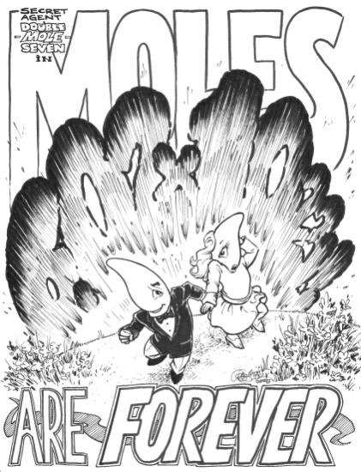
Name: ______________________ Period:______________Partner:___________________

Group 1: Fun with Moles!
Solve the problems below. When you get the answer, go to the appropriate card on the wall. Copy the word on the back in the correct space. When you have finished all five problems and you have a sentence, bring it to the front. Bonus points are assigned in order of completion. First group to solve their sentence gets 5 bonus points. Second group gets 4 bonus points. Third group gets 3 bonus points. Fourth group gets 2 bonus points. Every group after that gets 1 bonus point.

Word | Problem | Answer
 | How many moles of Pb are in 2.3456 g of Pb?
 | How many atoms are present in 4.80 mol of Fe?
 | How many moles of K are in 5.7 x 10²³ atoms?
 | Calculate the number of atoms in 7.50 mol of S?
 | What is the molar mass of Na₂SO₄
 | What is the molar mass of C₆H₁₂O₆
 | How many moles are in 1459 g of erbium?

Name: ______________________ Period:______________Partner:___________________

Group 2: Fun with Moles!
Solve the problems below. When you get the answer, go to the appropriate card on the wall. Copy the word on the back in the correct space. When you have finished all five problems and you have a sentence, bring it to the front. Bonus points are assigned in order of completion. First group to solve their sentence gets 5 bonus points. Second group gets 4 bonus points. Third group gets 3 bonus points. Fourth group gets 2 bonus points. Every group after that gets 1 bonus point.

Word | Problem | Answer
 | What is the mass in grams of 0.850 mol of mietnerium?
 | How many particles are in 5.0 g of Fe
 | How many grams are in 3.0 mol Cu?
 | How many moles of silver are in 2.888 x 10²³ atoms?
 | How many moles of osmium are in 3.5 x 10²³ atoms?
 | How many moles of He are in 0.255 g He?
 | Calculate the mass in grams of 5.50 mol Na?

Name: ______________________ Period:______________Partner:___________________
Group 3: Fun with Moles!
Solve the problems below. When you get the answer, go to the appropriate card on the wall. Copy the word on the back in the correct space. When you have finished all five problems and you have a sentence, bring it to the front. Bonus points are assigned in order of completion. First group to solve their sentence gets 5 bonus points. Second group gets 4 bonus points. Third group gets 3 bonus points. Fourth group gets 2 bonus points. Every group after that gets 1 bonus point.

Word | Problem | Answer
 | How many moles are in 11.5 g of sodium?
 | What is the mass in grams of 0.0050 mol of uranium?
 | What is the mass in grams of 19.67 mol of gallium?
 | What is the mass in grams of 10.5 mol of nickel?
 | What is the mass in grams of 2.3456 mol of Pb?
 | What is the mass in grams of 1.0 mol of europium?
 | How many atoms are in 15.0 mol of zinc?

Name: ______________________ Period:______________Partner:___________________
Group 4: Fun with Moles!
Solve the problems below. When you get the answer, go to the appropriate card on the wall. Copy the word on the back in the correct space. When you have finished all five problems and you have a sentence, bring it to the front. Bonus points are assigned in order of completion. First group to solve their sentence gets 5 bonus points. Second group gets 4 bonus points. Third group gets 3 bonus points. Fourth group gets 2 bonus points. Every group after that gets 1 bonus point.

Word | Problem | Answer
 | What is the mass in grams of 0.850 mol of mietnerium?
 | What is the mass in grams of 19.67 mol of gallium?
 | What is the mass in grams of 10.5 mol of nickel?
 | How many moles are in 11.5 g of sodium?
 | How many moles of silver are in 2.888 x 10²³ atoms?
 | What is the mass in grams of 5.97 mol of erbium?
 | What is the mass in grams of 2.3456 mol of Pb?

Name: ______________________ Period:______________Partner:___________________

Group 5: Fun with Moles!
Solve the problems below. When you get the answer, go to the appropriate card on the wall. Copy the word on the back in the correct space. When you have finished all five problems and you have a sentence, bring it to the front. Bonus points are assigned in order of completion. First group to solve their sentence gets 5 bonus points. Second group gets 4 bonus points. Third group gets 3 bonus points. Fourth group gets 2 bonus points. Every group after that gets 1 bonus point.

Word | Problem | Answer
 | What is the mass in grams of 1.0 mol of europium?
 | How many particles are in 5.0 g of Fe
 | How many moles of K are in 5.7 x 10²³ atoms?
 | Calculate the number of atoms in 7.50 mol of S?
 | What is the mass in grams of 0.0050 mol of uranium?
 | How many moles of He are in 0.255 g He?
 | Calculate the mass in grams of 5.50 mol Na?
Name: ______________________ Period:______________Partner:___________________

Group 6: Fun with Moles!
Solve the problems below. When you get the answer, go to the appropriate card on the wall. Copy the word on the back in the correct space. When you have finished all five problems and you have a sentence, bring it to the front. Bonus points are assigned in order of completion. First group to solve their sentence gets 5 bonus points. Second group gets 4 bonus points. Third group gets 3 bonus points. Fourth group gets 2 bonus points. Every group after that gets 1 bonus point.

Word | Problem | Answer
 | Calculate the number of atoms in 7.50 mol of S?
 | What is the mass in grams of 0.0050 mol of uranium?
 | What is the mass in grams of 1.0 mol of europium?
 | How many particles are in 5.0 g of Fe
 | How many grams are in 3.0 mol Cu?
 | How many moles of silver are in 2.888 x 10²³ atoms?
 | What is the mass in grams of 0.850 mol of mietnerium?

