Heating Curve Name__________________
Homework Date____________Per____
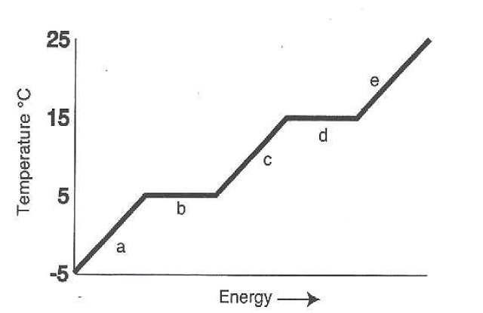

ANSWER THE FOLLOWING USING THE ABOVE HEATING CURVE

- What is the melting temperature of the above substance? _____

- What is the freezing temperature of the above substance? _____

- What is the boiling temperature of the above substance? _____

- The part of the graph labeled “e” represents temperatures at which gas is being heated. Describe what is happening for each of the other lettered sections of the graph:

- ___________________________________________________________
- ___________________________________________________________
- ___________________________________________________________
- ___________________________________________________________

- In which section of the graph are atoms moving the least? ___________
- In which section of the graph is this substance all liquid? ____________
- On your graph, draw an arrow to and label each of the following: “melting begins”, “melting complete”, and “boiling begins”.

