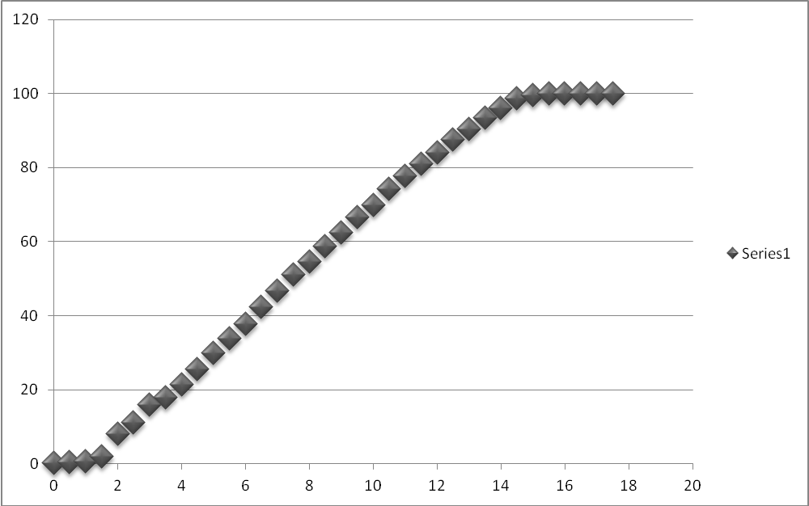
Time (Min) | Temp (Celsius) | Time (Min) | Temp (Celsius)
0 | 0.1 | 9 | 62.4
0.5 | 0.5 | 9.5 | 66.6
1 | 0.7 | 10 | 69.8
1.5 | 2 | 10.5 | 74.1
2 | 8 | 11 | 77.7
2.5 | 11 | 11.5 | 80.9
3 | 15.9 | 12 | 83.9
3.5 | 17.8 | 12.5 | 87.6
4 | 21.3 | 13 | 90.4
4.5 | 25.5 | 13.5 | 93.5
5 | 29.9 | 14 | 96.1
5.5 | 33.7 | 14.5 | 98.6
6 | 37.8 | 15 | 99.4
6.5 | 42.4 | 15.5 | 100
7 | 46.6 | 16 | 100
7.5 | 51.1 | 16.5 | 100
8 | 54.6 | 17 | 100
8.5 | 58.6 | 17.5 | 100

