Heating and Cooling Curves
This is an example of water – can be done with any substance but the temperature values and C and L values will be different. Also please note that the slope and length of lines are not drawn to scale. It is traditional to just draw the heating curve. A cooling curve would just be the opposite direction!
5
Cooling Curve
100°C
0°C
Q = mC_{steam}∆T
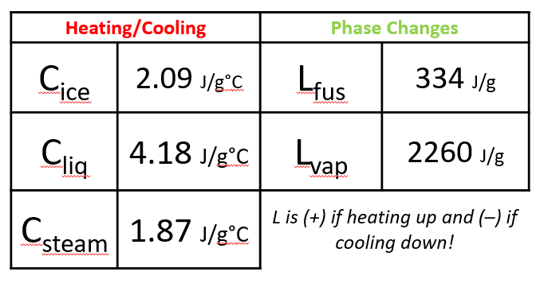
Latent Heat Values for H₂O
L_{fus} = 334 $\frac{J}{g}$
L_{vap} = 2260 $\frac{J}{g}$
4
3
2
1
Freezing point
Boiling point
Q = mL_{vaporization}
Q = mL_{fussion}
Q = mC_{ice}∆T
Q = mC_{liquid}∆T
Heating Gas
Cooling Gas
Heating Liquid
Cooling Liquid
Heating Solid
Cooling Solid
Vaporizing
Condensing
Melting
Freezing

Q = mC∆T
Variable | Meaning | Common Units
Q | Energy being transferred | Joules, kJ, calorie, Calorie
m | Mass of sample | grams, kilograms
C | Specific Heat | J/g°C, kJ/g°C
∆T | Change in Temperature | °C

Note:
- Temperature is in CELSIUS not Kelvins for this topic!
- Q can be positive or negative, energy absorbed or energy released
- 1 kJ = 1000 J
- 1 calorie = 4.18 J
- 1 Calorie = 1 kcal = 1000 calories
- Specific Heat values can vary a little bit from source to source. That is ok. Depends on the exact type that was measured. Feel free to add other specific heats you come across to this list!

Common Specific Heat Values
Substance | J/g°C | cal/g°C
Aluminum | 0.90 | 0.23
Copper | 0.39 | 0.093
Ethanol | 2.44 | 0.58
Glass | 0.50 | 0.12
Gold | 0.13 | 0.031
Graphite | 0.71 | 0.17
Ice | 2.09 | 0.50
Iron | 0.45 | 0.11
Lead | 0.13 | 0.031
Mercury | 0.14 | 0.033
Silver | 0.24 | 0.057
Steam | 1.87 | 0.45
Water (liq) | 4.18 | 1.00
Wood | 1.8 | 0.42

