Rates of Reaction Worksheet
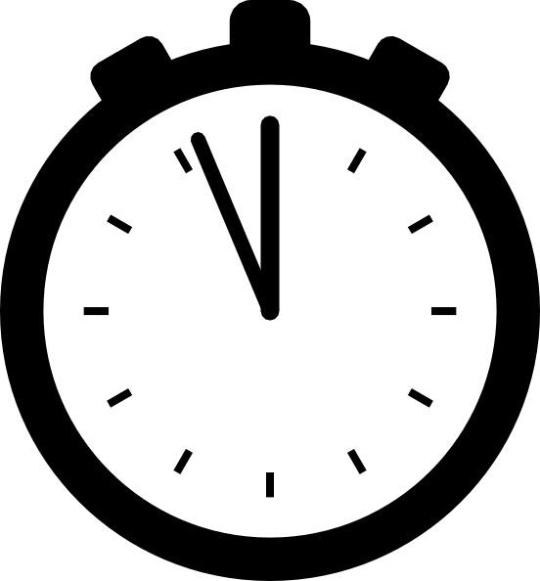
- Solid phosphorus and oxygen gas react to form tetraphosphorus decoxide. Determine the average rate of reaction for oxygen during the first 40 s if the concentration changes from 0.200 mol/L to 0.0001 mol/L during this time interval.

- At 40ºC, hydrogen chloride gas will form from the reaction of gaseous hydrogen and chlorine, according to the following balanced chemical equation: H₂ (g) + Cl₂ (g) → 2 HCl (g). Using the data provided, calculate the following average rates:
 | Concentration (mol/L)
Time (s) | H₂ (g) | Cl₂ (g) | HCl (g)
0 | 1.000 | 1.000 | 0.000
2.16 | 0.500 | 0.500 | 1.000
4.32 | 0.250 | 0.250 | 1.500

- hydrogen gas in the first 2.16 s.
- hydrogen chloride gas in the first 4.32 s
- chlorine gas between 2.16 s & 4.32 s
- hydrogen gas in the first 4.32 s

- Hydrogen peroxide in aqueous solution will decompose to produce oxygen gas and water. Use the graph to:
- Calculate the average reaction rate of hydrogen peroxide between 0 s and 5 s.
- Calculate the average reaction rate for the oxygen gas between 0 s and 2 s.
- Calculate the average reaction rate for the oxygen gas between 2 s and 4 s.
- Calculate the average reaction rate for the oxygen gas between 4 s and 6 s.
- Calculate the average reaction rate for the oxygen gas between 6 s and 8 s.
- Using your answers for 3b-3e, is the rate of a reaction a constant value from start to finish? Why do you think it is or isn’t a constant value? What is causing the rate to stay the same or change?

Rates of Reaction Worksheet
- Solid phosphorus and oxygen gas react to form tetraphosphorus decoxide. Determine the average rate of reaction for oxygen during the first 40 s if the concentration changes from 0.200 mol/L to 0.0001 mol/L during this time interval.

- At 40ºC, hydrogen chloride gas will form from the reaction of gaseous hydrogen and chlorine, according to the following balanced chemical equation: H₂ (g) + Cl₂ (g) → 2 HCl (g). Using the data provided, calculate the following average rates:
 | Concentration (mol/L)
Time (s) | H₂ (g) | Cl₂ (g) | HCl (g)
0 | 1.000 | 1.000 | 0.000
2.16 | 0.500 | 0.500 | 1.000
4.32 | 0.250 | 0.250 | 1.500
 | Concentration (mol/L)
Time (s) | H₂ (g) | Cl₂ (g) | HCl (g)
0 | 1.000 | 1.000 | 0.000
2.16 | 0.500 | 0.500 | 1.000
4.32 | 0.250 | 0.250 | 1.500
- hydrogen gas in the first 2.16 s.
- hydrogen chloride gas in the first 4.32 s
- chlorine gas between 2.16 s & 4.32 s
- hydrogen gas in the first 4.32 s

- Hydrogen peroxide in aqueous solution will decompose to produce oxygen gas and water. Use the graph to:
- Calculate the average reaction rate of hydrogen peroxide between 0 s and 5 s.
- Calculate the average reaction rate for the oxygen gas between 0 s and 2 s.
- Calculate the average reaction rate for the oxygen gas between 2 s and 4 s.
- Calculate the average reaction rate for the oxygen gas between 4 s and 6 s.
- Calculate the average reaction rate for the oxygen gas between 6 s and 8 s.
- Using your answers for 3b-3e, is the rate of a reaction a constant value from start to finish? Why do you think it is or isn’t a constant value? What is causing the rate to stay the same or change?

