**Name: Period: Seat #:**

This assignment, regarding the collision theory, will be completed by you the student. Please read and complete assignments below. Some of the links you will visit contain animations that may take some time to load. So, be patient. Short and brief answers are acceptable. Credit to <http://www.mcs-science.com/collision-theory---done.html>

**Task A – Link works, check 4/17/18**

Visit: <http://www.chemguide.co.uk/physical/basicrates/introduction.html> - Read the information describing the collision theory. Answer the questions that follow.  
Questions:   
1. Define the Collision Theory in your own words.

|  |
| --- |
|  |

2. It is pretty obvious that if you have a situation involving two reactants they can only react together if they come into contact with each other. They first have to collide, and then they *may* react. Why "*may* react"? What are the two criteria that must be met to create an EFFECTIVE COLLISION?

|  |
| --- |
|  |

3. What is activation energy?

|  |
| --- |
|  |

Top of Form

Bottom of Form

**Task B – “use this link” works, checked 4/17/18**

Visit: [http://www.southaxholme.doncaster.sch.uk/subjects/animations/showcase page 6/collision theory.swf](http://www.southaxholme.doncaster.sch.uk/subjects/animations/showcase%20page%206/collision%20theory.swf) - The animation discusses the effects that concentration, surface area, temperature, and stirring have on a reaction. Be sure to visit each of the factors and "view" (Click on the eyes.) Answer the questions that follow.  
Questions: **USE THIS LINK**🡪 [http://www.ks8cience.co.uk/animations/collision.htm](http://www.kscience.co.uk/animations/collision.htm)   
1.    What effect does concentration have on the rate of a reaction? Explain why using the collision theory.

|  |
| --- |
|  |

2.    What effect does surface area have on the rate of a reaction? Explain why using the collision theory.

|  |
| --- |
|  |

3.    What effect does temperature have on the rate of a reaction? Explain why using the collision theory.

|  |
| --- |
|  |

4.    What effect does stirring have on the rate of reaction? Explain why using the collision theory.

|  |
| --- |
|  |

Top of Form

Bottom of Form

**Top of Form**

**Bottom of Form**

**Task C – Link works, checked 4/17/18**

Visit: <http://www.bom.gov.au/lam/Students_Teachers/ozanim/ozoanim.shtml> Watch the animation which demonstrates how ozone is destroyed by chlorofluorocarbons (CFC's). (Note: You can control the speed of the animation by clicking on the buttons to the right of the animation.) Also, please read the information that follows on the webpage. Then, answer the questions that follow.   
1.     What is ozone?

|  |
| --- |
|  |

2.     What is the importance of the ozone layer?

|  |
| --- |
|  |

3.     How is ozone destroyed?

|  |
| --- |
|  |

4.     In reaction CFCl3 + UV Light --> CFCl2 + Cl, there is only one reactant (CFCl3) and no collision. So, why did a reaction take place?

|  |
| --- |
|  |

Top of Form

Bottom of Form

**Task D** Go to this website and answer the following questions. <http://www.kentchemistry.com/links/Kinetics/FactorsAffecting.htm> View the videos and diagrams.

What is a catalyst?

|  |
| --- |
|  |

List 2 things that a catalyst does in a reaction? Explain each of these actions in detail.

|  |
| --- |
|  |

What determines whether a substance can be considered a catalyst or not?

|  |
| --- |
|  |

Also review these websites and Find and insert 2 reaction coordinate graphs. One exothermic reaction with and without a catalyst (label all parts) and an endothermic reaction with and without a catalyst.

|  |
| --- |
|  |

The below link can help too…

<http://www.800mainstreet.com/7/0007-004-reac_rate2.htm>

**Task E:**

Review the data from an experiment below and answer the questions:

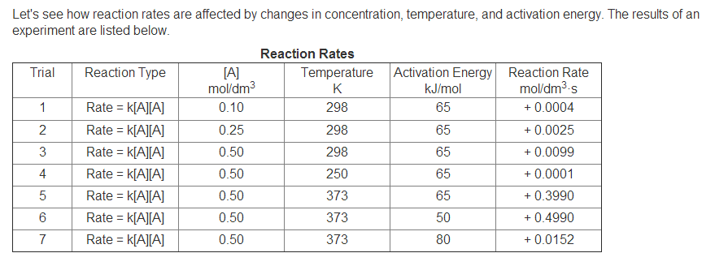

**Data Analysis**

1. Compare the reaction rates for Trials 2 and 3. When the concentration of A doubles, the reaction rate increases by what factor? Show how you got this answer

|  |
| --- |
|  |

1. Compare Trials 3-5. What effect does temperature have on reaction rate?

|  |
| --- |
|  |

1. Compare Trials 5-7. What effect does activation energy have on reaction rate?

|  |
| --- |
|  |

1. Which trial could represent how reaction rate is affected by the presence of a catalyst? Explain.

|  |
| --- |
|  |

1. Inhibitors act like catalysts, but they slow down reactions rather than speeding them up. Which trial could represent how reaction rate is affected by the presence of an inhibitor? Explain.

|  |
| --- |
|  |

Top of Form