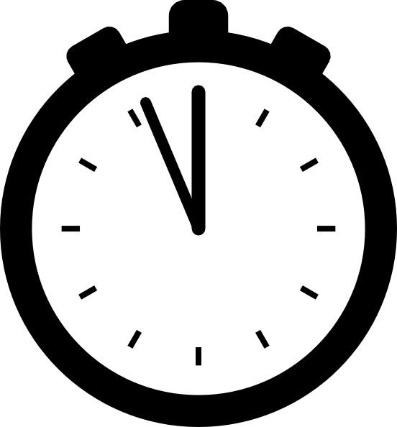
Rates of Reaction Worksheet

- Solid phosphorus and oxygen gas react to form tetraphosphorus decoxide. Determine the average rate of reaction for oxygen during the first 40 s if the concentration changes from 0.200 mol/L to 0.000 mol/L during this time interval.

- At 40ºC, hydrogen chloride gas will form from the reaction of gaseous hydrogen and chlorine, according to the following balanced chemical equation: H₂ (g) + Cl₂ (g) → 2 HCl (g). Using the data provided, calculate the following average rates:

- disappearance of hydrogen gas in the first 2.16 s.
 | Concentration (mol/L)
Time (s) | H₂ (g) | Cl₂ (g) | HCl (g)
0 | 1.000 | 1.000 | 0.000
2.16 | 0.500 | 0.500 | 1.000
4.32 | 0.250 | 0.250 | 1.500
(0.231 mol/L.s)
- appearance of hydrogen chloride gas in the first 4.32 s
(0.347 mol/L.s)
- disappearance of chlorine gas between 2.16 s and 4.32 s (0.116 mol/L.s)
- disappearance of hydrogen gas in the first 4.32 s
(0.174 mol/L.s)

- Hydrogen peroxide in aqueous solution will decompose to produce oxygen gas and water. Use the graph to the right to:

- calculate the average reaction rate for the appearance of oxygen gas between 5 s and 10 s.

- calculate the average reaction rate of disappearance of hydrogen peroxide between 0 s and 5 s.

- calculate the instantaneous rate of appearance of oxygen gas at 4 s.

- Ammonia gas and oxygen gas react to form nitric oxide and water vapour. The instantaneous rate of consumption of ammonia is 2.0x10⁻² mol/L at 10 s.
- Write and balance the chemical equation.
- Determine the instantaneous rate of oxygen gas consumption at 10 s. (2.2x10⁻² mol/L.s)
- Determine the instantaneous rate of water vapour appearance at 10 s. (2.7x10⁻² mol/L.s)

