**Name: Period: Seat#:**

**Chapter #1**

*Fill out once school starts*

**Directions:** Show work for ANY mathematical calculations, and show annotations/explanations for any non-mathematical questions.

1. Sodium is mixed with water and a violent reaction between the metal and water is seen. This is best classified as:
   1. An observation
   2. A law
   3. A hypothesis
   4. A theory
2. This image represents a particulate view of a sample of matter. Classify the sample according to its composition.
   1. 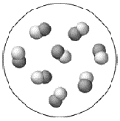The sample is a pure element.
   2. The sample is a homogeneous mixture.
   3. The sample is a compound.
   4. The sample is a heterogeneous mixture.
3. Which change is a physical change?
   1. wood burning
   2. iron rusting
   3. dynamite exploding
   4. gasoline evaporating
4. Which property of rubbing alcohol is a chemical property?
   1. density (0.786 g/cm3)
   2. flammability
   3. boiling point (82.5 °C)
   4. melting point (–89 °C)
5. Convert 85.0 °C to K.
   1. 181.1 K
   2. 358 K
   3. 29.4 K
   4. 302.6 K
6. Express the quantity 33.2 × 10−4 m in mm.
   1. 33.2 mm
   2. 3.32 mm
   3. 0.332 mm
   4. 3.32 × 10−6 mm
7. A 1.75 L sample has a density of 0.921 g/mL. Find the mass.
   1. 1.61 × 103 g
   2. 1.61 × 10−3 g
   3. 1.90 × 103 g
   4. 1.90 × 10−3 g
8. Perform the calculation to the correct number of significant figures. (43.998 × 0.00552)/2.002
   1. 0.121
   2. 0.12
   3. 0.12131
   4. 0.1213
9. Calculate with the correct number of significant figures.

(8.01 − 7.50)/3.002

* 1. 0.1698867
  2. 0.17
  3. 0.170
  4. 0.1700

1. Convert 1285 cm2 to m2
   1. 1.285 x 107 m2
   2. 12.85 m2
   3. 0.1285 m2
   4. 1.285 x 105 m2
2. The first diagram depicts a compound in its liquid state. Which of the other diagrams best depicts the compound after it has evaporated into a gas?

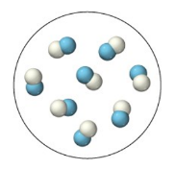LIQUID: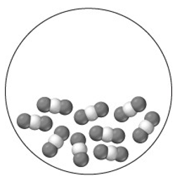 a. 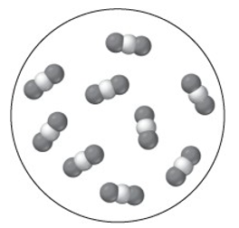 b. 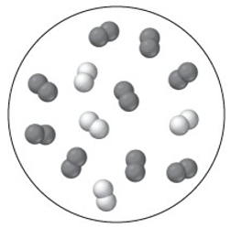

c. 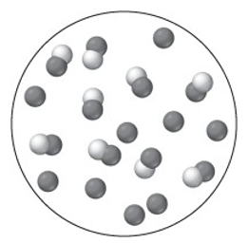 d.

1. Three samples, each of a different substance, are weighed and their volume is measured. The results are tabulated. List the substances in order of decreasing density.
   1. 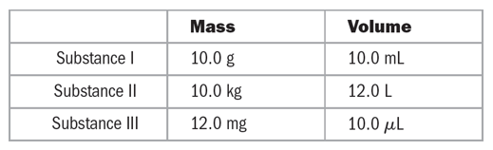III > II > I
   2. I > II > III
   3. III > I > II
   4. II > I > III
2. A solid metal sphere has a radius of 3.53 cm and a mass of 1.796 kg. What is the density of the metal in g/cm3 ? (The volume of a sphere is V = )
   1. 34.4 g/cm3
   2. 0.103 g/cm3
   3. 121 g/cm3
   4. 9.75 g/cm3
3. The gas mileage of a certain German automobile is 22 km/L. Convert this quantity to miles per gallon.
   1. 9.4 mi/gal
   2. 1.3 × 102 mi/gal
   3. 52 mi/gal
   4. 3.6 mi/gal
4. A wooden block has a volume of 18.5 in3 . Express the volume of the cube in cm3.
   1. 303 cm3
   2. 47.0 cm3
   3. 1.13 cm3

**Answers**

**1)** A **6)** B **11)** A

**2)** C **7)** A **12)** C

**3)** D **8)** A **13)** D

**4)** B **9)** B **14)** C

**5)** B **10)** C **15)** A

* 1. 7.28 cm3

1. Two samples of a compound containing elements A and B are decomposed. The first sample produces 15 g of A and 35 g of B. The second sample produces 25 g of A and what mass of B?
   1. 11 g
   2. 58 g
   3. 21 g
   4. 45 g
2. A compound containing only carbon and hydrogen has a carbon-to- hydrogen mass ratio of 11.89. Which carbon-to-hydrogen mass ratio is possible for another compound composed only of carbon and hydrogen?
   1. a. 2.50
   2. b. 3.97
   3. 4.66
   4. 7.89
3. Which idea came out of Rutherford’s gold foil experiment?
   1. Atoms contain protons and neutrons.
   2. Matter is composed of atoms.
   3. Elements have isotopes.
   4. Atoms are mostly empty space.
4. JJ Thomson’s Cathode Ray experiment determined the charge on an electron as being negative. How did his experiment determine this?
   1. The beam of electrons bent towards the positive side of a magnet and away from the negative end
   2. The beam of electrons bent away from the positive side of a magnet and towards the negative side
5. Determine the number of protons and neutrons in the isotope Fe-58.
   1. 26 protons and 58 neutrons
   2. 32 protons and 26 neutrons
   3. 26 protons and 32 neutrons
   4. 58 protons and 58 neutrons
6. An isotope of an element contains 82 protons and 122 neutrons. What is the symbol for the isotope?
${}_{82}^{204}{Pb}$

${}_{82}^{122}{Pb}$

${}_{40}^{122}{Zr}$

${}_{40}^{204}{Zr}$

7. Determine the number of electrons in the Cr3+ ion.
   1. 24 electrons
   2. 27 electrons
   3. 3 electrons
   4. 21 electrons
8. Which pair of elements do you expect to be most similar in their chemical properties?
   1. K and Fe
   2. O and Si
   3. Ne and N
   4. Br and I
9. Which element is not a main-group element?
   1. Se
   2. Mo
   3. Sr
   4. Ba

**Chapter #2**

1. What is the charge of the ion most commonly formed by S?
   1. 2+
   2. +
   3. –
   4. 2-
2. A naturally occurring sample of an element contains only two isotopes. The first isotope has a mass of 68.9255 amu and a natural abundance of 60.11%. The second isotope has a mass of 70.9247 amu. Find the atomic mass of the element.
   1. 70.12 amu
   2. 69.72 amu
   3. 84.06 amu
   4. 69.93 amu
3. Which sample contains the greatest number of atoms?
   1. 14 g C
   2. 49 g Cr
   3. 102 g Ag
   4. 202 g Pb
4. Determine the number of atoms in 1.85 mL of mercury.   
   (The density of mercury is 13.5 g/mL.)
   1. 3.02 × 1027 atoms
   2. 4.11 × 1020 atoms
   3. 7.50 × 1022 atoms
   4. 1.50 × 1025 atoms
5. A 20.0 g sample of an element contains 4.95 × 1023 atoms. Identify the element.
   1. Cr
   2. O
   3. Mg
   4. Fe
6. 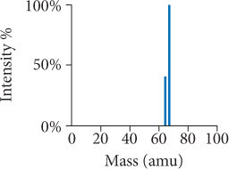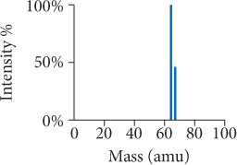Copper has two naturally occurring isotopes with masses 62.94 amu and 64.93 amu and has an atomic mass of 63.55 amu. Which mass spectrum is most likely to correspond to a naturally occurring sample of copper?

* 1. 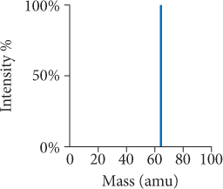 b.

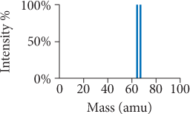

c. d.

**Answers**

**1)** B **6)** A **11)** B

**2)** B **7)** D **12)** A

**3)** D **8)** D **13)** C

**4)** A **9)** B **14)** C

**5)** C **10)** D **15)** A

1. What is the empirical formula of a compound with the molecular formula C10H8 ?
   1. C5H3
   2. C2H4
   3. C5H4
   4. CH
2. Which substance is an ionic compound?
   1. SrI2
   2. N2O4
   3. He
   4. CCl4
3. What is the correct formula for the compound formed between calcium and sulfur?
   1. CaS
   2. Ca2S
   3. CaS2
   4. CaS3
4. Name the compound SrI2.
   1. strontium iodide
   2. strontium diiodide
   3. strontium(II) iodide
   4. strontium(II) diiodide
5. What is the formula for manganese(IV) oxide?
   1. Mn4O
   2. MnO4
   3. Mn2O
   4. MnO2
6. Name the compound Pb(C2H3O2)2
   1. lead(II) carbonate
   2. lead(II) acetate
   3. lead bicarbonate
   4. lead diacetate
7. Name the compound P2I4.
   1. phosphorus iodide
   2. phosphorus diiodide
   3. phosphorus(II) iodide
   4. diphosphorus tetraiodide
8. Name the compound HNO2 (aq).
   1. hydrogen nitrogen dioxide
   2. hydrogen nitrate
   3. nitric acid
   4. nitrous acid
9. Determine the number of CH2Cl2 molecules in 25.0 g CH2Cl2.
   1. 0.294 molecules
   2. 1.77 × 1023 molecules
   3. 1.28 × 1027 molecules
   4. 1.51 × 1025 molecules
10. List the elements in the compound CF2Cl2 in order of decreasing mass percent composition.
    1. C > F > Cl
    2. F > Cl > C
    3. Cl > C > F
    4. Cl > F > C

**Chapter #3**

1. Determine the mass of potassium in 35.5 g of KBr.
   1. 17.4 g
   2. 0.298 g
   3. 11.7 g
   4. 32.9 g
2. A compound is 52.14% C, 13.13% H, and 34.73% O by mass. What is the empirical formula of the compound?
   1. C2H8O3
   2. C2H6O
   3. C4HO3
   4. C3HO6
3. A compound has the empirical formula CH2O and a formula mass of 120.10 amu. What is the molecular formula?  
   1. CH2O
   2. C2H4O2
   3. C3H6O3
   4. C4H8O4
4. Combustion of 30.42 g of a compound containing only carbon, hydrogen, and oxygen produces 35.21 g CO2 and 14.42 g H2O. What is the empirical formula? *(takes a lot of space so don’t forget to notice Q#15 at the very bottom!)*
   1. C4H8O6
   2. C2H4O3
   3. C2H2O3
   4. C6HO12

1. What are the correct coefficients (reading from left to right) when the chemical equation is balanced?

__PCl3(l) + __H2O(l) → __H3PO3 (aq) + __HCl(aq)

* 1. 1, 3, 1, 3
  2. 1, 2, 1, 1
  3. 1, 3, 2, 1
  4. 3, 6, 1, 9

**Answers**

**1)** C **6)** B **11)** C

**2)** A **7)** D **12)** B

**3)** A **8)** D **13)** D

**4)** A **9)** B **14)** B

**5)** D **10)** D **15)** A

1. 3 MnO2 + 4 Al → 3 Mn + 2 Al2O3

What mass of Al is needed to fully react with 25.0 g MnO2 ?

* 1. 7.76 g Al
  2. 5.82 g Al
  3. 33.3 g Al
  4. 10.3 g Al

1. 2Na(s) + Cl2(g) → 2 NaCl(s)

What is the theoretical yield of sodium chloride for the reaction of 55.0 g Na with 67.2 g Cl2?

* 1. 1.40 × 102 g
  2. 111 g
  3. 55.4 g
  4. 222 g

1. Sulfur and fluorine react to form sulfur hexafluoride:  
    S(s) + 3 F2(g) → SF6(g)

If 50.0 g S is allowed to react as completely as possible with 105.0 g F2, what mass of the excess reactant is left?

* 1. 20.5 g S
  2. 45.7 g F2
  3. 15.0 g S
  4. 36.3 g F2

1. A reaction has a theoretical yield of 45.8 g. When the reaction is carried out, 37.2 g of the product is obtained. What is the percent yield?
   1. 55.1%
   2. 44.8%
   3. 123%
   4. 81.2%
2. What is the molarity of a solution containing 55.8 g of MgCl2 dissolved in 1.00 L of solution?
   1. 55.8 M
   2. 1.71 M
   3. 0.586 M
   4. 0.558 M
3. What mass (in grams) of Mg(NO3)2 is present in 145 mL of a 0.150 M solution of Mg(NO3)2 ?
   1. a. 3.23 g
   2. b. 0.022 g
   3. c. 1.88 g
   4. d. 143 g
4. What volume of a 1.50 M HCl solution should you use to prepare 2.00 L of a 0.100 M HCl solution?
   1. 0.300 L
   2. 0.133 L
   3. 30.0 L
   4. 2.00 L

**Chapter #4**

1. 2 KI(aq) + Pb(NO3)2 (aq) → 2 KNO3(aq) + PbI2(s)

What minimum volume of 0.200 M potassium iodide solution is required to completely precipitate all of the lead in   
155.0 mL of a 0.112 M lead(II) nitrate solution?

* 1. 348 mL
  2. 86.8 mL
  3. 174 mL
  4. 43.4 Ml

1. Which solution forms a precipitate when mixed with a solution of aqueous Na2CO3 ?
   1. KNO3(aq)
   2. NaBr(aq)
   3. NH4Cl(aq)
   4. CuCl2 (aq)
2. What is the net ionic equation for the reaction that occurs when aqueous solutions of KOH and SrCl2 are mixed?
   1. K+ (aq) + Cl− (aq) 🡪 KCl(s)
   2. Sr2+ (aq) + 2 OH− (aq) 🡪 Sr(OH)2 (s)
   3. H+ (aq) + OH− (aq) → H2O (l)
   4. None of the above because no reaction occurs
3. What is the net ionic equation for the reaction that occurs when aqueous solutions of KOH and HNO3 are mixed?
   1. K+ (aq) + NO− (aq) 🡪 KNO3 (s)
   2. NO− (aq) + OH− (aq)🡪 NO3OH (s)
   3. H+ (aq) + OH− (aq) 🡪 H2O (l)
   4. None of the above because no reaction occurs.
4. What is the net ionic equation for the reaction that occurs when aqueous solutions of KHCO3 and HBr are mixed?
   1. K+ (aq) + C2H3O2- (aq) 🡪 KC2H3O2 (s)
   2. H+ (aq) + HCO3- (aq) 🡪 CO2 (g) + H2O (l)
   3. H+ (aq) + OH- (aq) 🡪 H2O (l)
   4. None of the above because no reaction occurs.
5. What is the oxidation state of carbon in CO32- ?
   1. +4
   2. +3
   3. -3
   4. -2
6. 2Na (s) + 2H2O (l) 🡪 2NaOH (aq) + H2 (g)  
   Identify the oxidizing agent.
   1. Na (s)
   2. H2O (l)
   3. NaOH (aq)
   4. H2 (aq)
7. Identify the correct balanced equation for the combustion of propane C3H8
   1. C3H8 (g) → 4 H2 (g) + 3 C (s)
   2. C3H8 (g) + 5 O2 (g) → 4 H2O (g) + 3 CO2 (g)
   3. C3H8 (g) + 3 O2 (g) → 4 H2O (g) + 3 CO2 (g)
   4. 2 C3H8 (g) + 9 O2 (g) → 6 H2CO3 (g) + 2 H2 (g)

**Answers**

**1)** D **6)** A **11)** C

**2)** B **7)** B **12)** B

**3)** A **8)** C **13)** A

**4)** D **9)** D **14)** B

**5)** C **10)** B **15)** B